Testimonials

Chabad of New Canaan
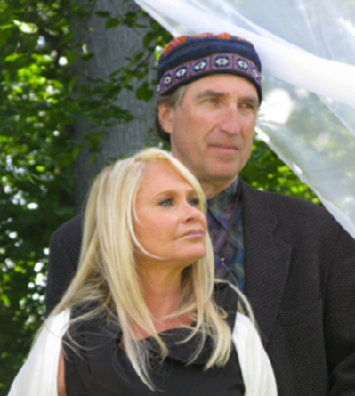
When my wife, Melody, and I decided to participate in the legacy program on behalf of Chabad of New Canaan, we agreed it was critical to talk to our adult children first.
It was essential for us to reinforce to them what it means to us to be Jews, and what Judaism meant to our parents and our parents’ parents.
We emphasized to our adult children why it is important for us to have children and grandchildren who value the Jewish heritage — and why we find it especially important to support a strong Jewish presence in New Canaan.
We also described how a modest slice of our estate can help to ensure the durability and vitality of Jewish life in New Canaan. Not just in our lifetime, but long afterward.
We appreciate that Chabad of New Canaan, for more than a decade, has provided our community with the means to live a joyous and fulfilling Jewish life. We value their lifelong learning programs, personal counseling, Hebrew school for children, and their wide range of holiday, ritual and life cycle offerings.
Interestingly, we found the actual process of establishing a legacy gift to be relatively easy, once we opted to move forward.

Ilan and Lenore Fogel Testimonial
Lenore and I moved to the city of Stamford in 2004 and have felt at home since the moment we arrived. Never before have we lived in a community where all the organizations work so diligently to come together for the good of the whole. The two of us and our five children who have grown up here, have been blessed to benefit from such a wide variety of options and opportunities, and to have so many places where we feel a sense of belonging.
We were both raised by parents who believed in the strength of community in and its power. They showed us by their actions what it means to build a place where all different types of people can find their niche. As you might imagine, raising five children close in age can make it difficult to share all that we would like with all of the organizations that we love. LIFE & LEGACY® is another avenue for us to feel that we will be able to give to the future of our home that we love so much. What a gift!

Testimonial for Life and Legacy by Lorraine and David Kweskin
The Kweskin and Plotkin families have always been immersed in the Stamford Jewish Community. Our mothers were Hadassah members, and Sisterhood Presidents, our fathers bowled for the Jewish Center League and both families actively supported their synagogues (Agudath and Beth El). We were born and raised in Stamford; David’s mother and father were born here as well. With one exception, our grandparents also raised their families locally. So, there is a rich history of connection to the Jewish community and the city of Stamford.
We became awakened to the global Jewish community through our involvement with United Jewish Federation. We visited countries that had been in the sphere of the former Soviet Union whose Jewish citizens were experiencing serious challenges of aging and Jewish identity. These are the same countries that our grandparents and great grandparents left and came to America for opportunity and to escape antisemitism. Our Israel missions with the Stamford community sparked deeper connections to our faith, our People. These insights broadened our view of the Jewish world and magnified our involvement with Israel.
Life and Legacy is the obvious choice to nourish these Jewish communities and to support Jewish organizations (both locally and worldwide).
We have never been people of overwhelming means, however, we do have an overwhelming commitment to the Jewish world. It is our prayer that by joining Life and Legacy we can keep our commitment alive through financial support while at the same time setting an example for our children and grandchildren.

Beverly & David Stein Testimonial
We moved to Stamford in 1990 with our two daughters. We immediately became involved in the United Jewish Federation and shortly after that Beverly became involved in Schoke Jewish Family Service.
Schoke JFS is where individuals and families in our community turn to when they are in need, or in crisis. They deliver essential services with compassion and respect and give people the tools they need to build healthier, more stable lives.
United Jewish Federation helps Jews at home, in Israel and overseas in a way no other organization does. We have traveled to Israel and been to visit Jewish communities (and former Jewish communities) Europe. We can’t imagine a world without Israel, and we have seen what a world without some of our destroyed communities looks like. If we as Jews don’t support Jews around the world, no one else will.
We are leaving Legacy gifts to Schoke JFS and UJF. A legacy gift is a lasting investment in our Jewish community. It helps to ensure that the Schoke JFS and UJF will be viable for future generations.
We are a community of individuals, but it is the institutions that are the beating heart of the community. Beverly is a President of the Schoke JFS board and we are both past Executive Committee members of UJF. It seems to us to be a no-brainer. We believe it is our responsibility to ensure that both organizations are able to continue their work into the future. We also want our children to know how much we value helping Jews in need everywhere.

