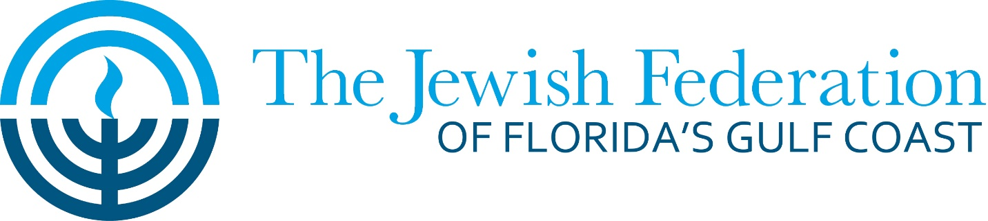

GUIDELINES FOR FEDERATION ALLOCATION REQUESTS FOR
FISCAL YEAR 2020-2021

The Jewish Federation of Florida’s Gulf Coast Budget and Allocations committee invites all area agencies and organizations offering Jewish programming to apply for funding through our Budget and Allocation process. All grant requests must meet the mission of the Jewish Federation: To raise and appropriate funds to rescue the imperiled, to care for the vulnerable, to strengthen Jewish life in Pinellas, Pasco and Hernando Counties, in Israel and throughout the world.

The Jewish Federation of Florida’s Gulf Coast is the central organizing body dedicated to building and strengthening the Jewish community in our region. Among its purposes are the following:

1. To nurture the quality of Jewish life.
2. To secure a favorable Jewish future for Pinellas, Pasco and Hernando Counties.
3. To promote Jewish learning and culture.
4. To promote Jewish values, practices and traditions which enrich Jewish life and identity.

Local beneficiary agencies are encouraged to submit as many program proposals as they deem appropriate. Agencies submitting more than one program proposal should prioritize the program requests.

Grants may be for new programs, currently-funded programs or for the replication of programs previously funded by the Jewish Federation of Florida’s Gulf Coast. Program grants will be issued for a one-year period.

Please submit proposals by noon on Monday, May 4, 2020
as a complete PDF package to: dmorin@jewishgulfcoast.org.

Submission Checklist

Please submit:
I. Grant Application & Program Budget
II. Statement of Intent
III. List of Board Members
IV. Financials
- Audited Financials or Equivalent
- Most recent 990
c. Confirmation of good standing with IRS

2020-21 GRANT APPLICATION

Date of submission ________________________________ Amount Requested _____________________

Organization Name _____________________________________________________________________

Address ______________________________________________________________________________

Phone number _______________ Fax number _______________ Email _________________________

Person(s) Submitting Application _________________________________

Name of Program __________________________________________________________________

- Program Summary

Is this a new program? an existing program? a replication?

If it is a replication, where and when was the original program? __________________________________________________________________________________________________________________________________________________________________________________________

For programs that are new or a replication of another program, please outline in 1,000 words or less the program goals, target population, implementation strategy and timeline, curriculum overview, staffing and place in institution. What percentage of the population served by this program is Jewish? What will be the number of people served? Describe the elements that will make this program successful, the interest in it and the resources available to it, including funds available from sources other than the Jewish Federation. Describe why you think the program should be funded and how the program relates to the goals of the Jewish Federation. Describe the effect you anticipate the program will have on the community you serve and the institution itself.

For existing programs that have been funded by the Federation before, please offer a short statement describing the program.

- Highlights of Your 2019-2020 Year

In 500 words or less, please provide highlights from your organization's year: your successes, challenges, staff and leadership changes, significant developments, and other points you feel relevant.

- About Last Year's Request

Describe in 500 words or less the success of last year's Federation-funded program (if applicable). Include amount of request, purpose, and outcomes.

- Additional Requests

i. Are there other non-cash requests you would make of the Federation at this time to help your organization become more effective, impactful, efficient, or otherwise better?

ii. If additional monies became available through the 2020-21 allocations process, please detail any additional programs or funding opportunities you would request. Please follow the "Program Summary" guideline above.

2020-21 STATEMENT OF INTENT

I/we understand that as a recipient of a grant from the Jewish Federation of Florida’s Gulf Coast, I/we will be required to submit the following in a timely manner to the Jewish Federation:
• A mid-year brief progress report, submitted to the Federation in January, 2021.
• All publicity and program materials related to Federation funding. Note language to be used below.

In addition, I/we agree to the following:
• I understand that no funds will be released by the Federation without fulfilling the grant requirements outlined above.
• My organization will acknowledge the Federation’s support on all printed materials produced in conjunction with the funded program by using the following language: "This program is made possible by the support of the Jewish Federation of Florida’s Gulf Coast". I will ensure we use the Federation's official logo on printed materials.
• I will ensure my organization lists the Federation as a supporter on all donor recognition materials, email blasts, and on our website.
• Strongly encourage my organizations board to give generously to the Federation’s campaign.
• I will ensure that volunteers from my board or organization are present at Super Sunday, and through our organization’s work will provide general Federation advocacy, partnership, and promotion.

Signed by: _______________________________ Printed Name and Title _______________________

_______________________

Institution __________________________________________ Date _______________________

*Note: these statements may be copied into an email and submitted to dmorin@jewishgulfcoast.org by each of these individuals if an in-person
signature is impractical.

