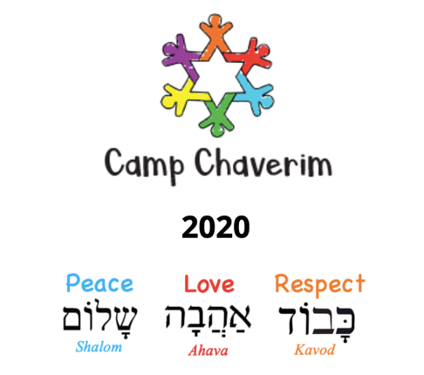
2020 Virtual Camp Chaverim Registration
Please Type or Print Clearly

Virtual Camp Chaverim will run the same dates originally planned for camp, Monday – Friday, June 1 – July 24, 2020. While Virtual Camp Chaverim is free, the number of campers we can accept is limited. We are inviting you to register your camper(s) today. If you want your child(ren) to be part of this year’s virtual camping experience, please return this form within three days to Rachel Johnson, the Jewish Federation’s Assistant Executive Director, at rachel@jfedokc.org.

Be sure you take advantage of ordering our special Virtual Camp Chaverim t-shirts - $10 for youth sizes and $12 for adult sizes! Please send checks or cash (no credit cards) for the order you indicate below to: Jewish Federation of Greater Oklahoma City, 710 West Wilshire Boulevard, Suite 103, Oklahoma City, OK 73116. Checks should be made out to “Jewish Federation” with “2020 Camp T-Shirts” noted in the memo section.

Parent(s)/Guardian(s) Information:

First | Last | Email | Phone

How will your camper(s) access the Internet for Virtual Camp Chaverim (circle all which apply)?
Desktop Laptop Tablet Smartphone

Camper(s) Information:

First | Last | Age | T-Shirt Size – Youth  S, M, L | T-Shirt Size – Adult  S, M, L, XL, XXL, XXXL

Additional Camp Chaverim T-Shirts not indicated above in the camper section:
- Youth Size: ___ Small, ___ Medium, ___ Large
- Adult Size: ___ Small, ___ Medium, ___ Large, ___ X-Large, ___ XX-Large, ___ XXX-Large

Total number of youth t-shirts: _____ x $10 = __________
Total number of adult t-shirts: _____ x $12 = __________
Total Amount Due for T-Shirts: $__________

