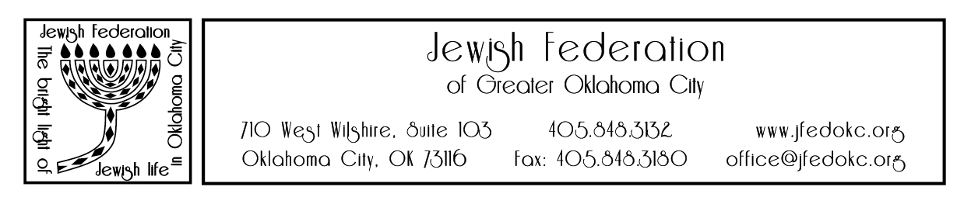

Jewish Federation of Greater Oklahoma City
80th Anniversary Celebration

Thursday, November 4, 6:00 p.m.
Honoring
Michael Baron, Producing Artistic Director, Lyric Theatre of Oklahoma

The Jewish Federation is planning a very special 80th Anniversary Celebration the evening of Thursday, November 4, 2021, at the Oklahoma City Golf and Country Club. The evening will include dinner, an ‘80s band, a look back on eight decades of the Jewish Federation’s work and a special tribute to Michael Baron, Producing Artistic Director of the Lyric Theatre of Oklahoma.

We invite you to support the important work of the Jewish Federation by becoming a sponsor of this special event. Each sponsor $1,800 and above will receive a table of 8 for the event and will be listed on the event invitation*, the printed program, and the Jewish Federation website.

- Celebration ($18,000)
- Don’t Stop Believing ($8,000)
- You’ve Got A Friend In Me ($3,800)
- The Time Of My Life ($2,800)
- A Night To Remember ($1,800)

Please print how your name/company is to be listed:

Payment: Enclosed check payable to the “Jewish Federation” Charge to my credit card

Charge Card: AmEx Discover MasterCard Visa

Credit Card #: Expiration Date: CVC:

Signature: Date:

Name: Phone:

Address:

City: State: _ Zip:

* The deadline for inclusion on the invitation is September 9, 2021.
Please return this completed form to the attention of Roberta S. Clark, Executive Director,
via email (roberta@jfedokc.org), or by mail to the Jewish Federation, 710 West Wilshire, Suite 103,
Oklahoma City, OK 73116.

