**Draft Collection Document: Templates, toolkits, guidance and information for faith-based and community based organizations and emergency managers on preparedness for houses of worship**

*Pre-Decisional Document Not for Public Distribution*

Contents

Purpose: 2

Why House of Worship Preparedness? 3

Example State & Local Government Resources 4

Georgia Emergency Management Agency Praise and Preparedness Program 4

Ready Northern Virginia Faith Developing Your Faith Organization Preparedness Plan Plug and Play Webpage 5

Example State and Government Resource Links 6

Example National Voluntary Organizations Active in Disasters and other Non-Profit Resources 7

American Red Cross Ready Rating Materials 7

National Disaster Interfaith Network Disaster Tipsheets 8

9

Example National Voluntary Organizations Active in Disasters and other Non-Profit Resources Links 9

Example Private Sector & Academic Resources 10

Brotherhood Mutual 10

University of Southern California Center for Religion and Civic Culture The Religious Literacy Primer for Crises, Disasters and Public Health Emergencies 11

Working with U.S. Faith Communities During Crises, Disasters and Public Health Emergencies: A Field Guide for Engagement, Partnerships and Religious Competency 11

University of Southern California Center for Religion and Civic Culture Faithful Action: Faith-Based Organizations and Disaster Response and Recovery Report 11

Johns Hopkins University Guided Preparedness Planning for Faith-Based Organizations 11

Wheaton College Humanitarian Disaster Institute 12

Drexel University The National Resource Center on Advancing Emergency Preparedness for Culturally Diverse Communities 12

Example Federal Government Resources 13

Guide for Developing Emergency Operations Plans for Houses of Worship 13

Safeguarding Houses of Worship Mobile App 14

Department of Justice Protecting Houses of Worship Event Resource Guide 14

Department of Homeland Security Hometown Security 15

Federal Emergency Management Agency Protecting Houses of Worship Webpage 15

Example Resource: United States Fire Administration Protecting Houses of Worship Against Arson Webpage 15

Department of Education: Readiness and Emergency Management for Schools (REMS) Technical Assistance Center 16

FEMA Children and Disasters Webpage 16

Individuals with Disabilities and Others with Access and Functional Needs Preparedness Webpage 16

Federal Government Links 17

# Purpose:

This document is a collection of information, guidance, templates, trainings and other information created to assist faith and community leaders increase the safety and security of their houses of worship for all disasters. Sources include members from a broad spectrum of the emergency management community which includes: federal government departments and agencies, the National Voluntary Organizations Active in Disasters, National Emergency Managers Association, International Association of Emergency Managers, academic institutions and the private sector. The following information and links to third party sites are provided for your reference. This compendium does not endorse any particular website, company, or application. The information provided here comes from the entities sponsoring each program or resource.

# Why House of Worship Preparedness?

*“From tiny storefront congregations to deep-pocketed denominations, the communities of faith arrived first. In the harrowing hours and days after Hurricane Katrina, when survivors roamed the desolate streets in search of water, food and medicine, church groups…provided dazed residents with their first hot meal, their first clean water, their first aspirin.”*

*FAITH IN ACTION Faith-based groups early and enduring Before agencies aided Katrina's victims, religious groups did - and still do.*- Amy Worden, Philadelphia Inquirer, August 23, 2006

Religion plays a central role in the lives of most Americans.

* 77% of Americans are affiliated with a religious tradition (Pew Forum on Religion & Public Life U.S. Religious Landscape Survey (2014), [http://religions.pewforum.org/reports](javascript:SendMeExternalURL2('http://religions.pewforum.org/reports'))).
* 38% of Americans would expect to rely on the faith-based community for assistance in the first 72 hours after a disaster (“[Preparedness in America](javascript:SendMeExternalURL2('http://www.fema.gov/media-library-data/1409000888026-1e8abc820153a6c8cde24ce42c16e857/20140825_Preparedness%20in%20America_August%202014%20Update_508.pdf')),” FEMA, August 2014).

In terms of numbers, there are approximately 345,000 congregations in the U.S., compared to 105,000 schools/universities. In fact, congregations are second only to retail stores and shops in the United States.[1]

While 71% of Americans identify as Christian, there are nearly 200 denominations and religious traditions in the US with representation from almost every major world religion. This brings social, cultural, ethnic, and linguistic diversity to both urban and rural settings.[2]

When considering the vast number of congregations and the role they play in American society, it should come as no surprise that faith transcends worship areas. People of faith may live, work, and worship in three different geographic areas.

This collection of resources was compiled to help any interested individual or organization seeking to increase the safety and security of houses of worship without having to reinvent the wheel.

Segments of this introduction are from [FEMA Independent Study course 505: Religious Literacy and Competency in Disasters](https://training.fema.gov/is/courseoverview.aspx?code=IS-505).

**Federal Government Resources**

# Example Federal Government Resources

## Guide for Developing Emergency Operations Plans for Houses of Worship

[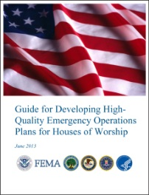](https://www.fema.gov/media-library/assets/documents/33007)This [guide provides houses of worship](https://www.fema.gov/media-library/assets/documents/33007) with information regarding emergency operations planning for the spectrum of threats and hazards they may face. It discusses actions that may be taken before, during, and after an incident in order to reduce the impact on property and any loss of life and it encourages every house of worship to develop an EOP.

The guide is organized in four sections:

1. The principles of emergency operations planning
2. A process for developing, implementing, and continually refining a house of worship’s EOP with community partners
3. A discussion of the form and function of a house of worship’s EOP
4. A closer look that discusses house of worship emergency planning in the event of an active shooter situation.

[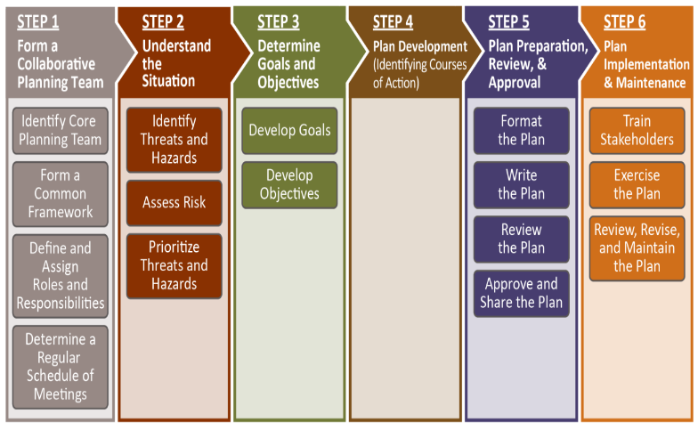](https://www.fema.gov/media-library/assets/documents/33007)Figure 1 depicts the six steps in the planning process. At each step in the planning process, houses of worship should consider the impact of their decisions on ongoing activities such as training and exercises, as well as on equipment and resources.

[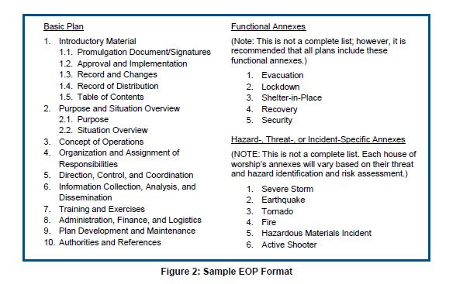](https://www.fema.gov/media-library/assets/documents/33007)In collaboration with other houses of worship and community partners (i.e., governmental entities that have a responsibility in the plan, including first responders, public health officials, and mental health officials), houses of worship can take steps to plan for these potential emergencies through the creation of an emergency operations

plan (EOP). Additionally, community organizations and private sector entities may have a role in the plan. Houses of worship are distinctive settings in that congregants share a common bond and have a predisposition to volunteer. The demographics of a congregation often mean that children and the elderly are present and may need assistance.

<https://www.fema.gov/media-library/assets/documents/33007>

**Federal Government Resources**

## Safeguarding Houses of Worship Mobile App

[](https://www.justnet.org/resources/Houses_of_Worship.html)National Institute Justice has created an app that will help local law enforcement work with houses of worship to evaluate facilities and create plans for preventing attacks and prepare for other catastrophic events. To access this FREE app, public safety officials should send the following information to [asknlectc@justnet.org](mailto:asknlectc@justnet.org) from your official agency email account

Type[**Safeguarding Houses of Worship App**](https://www.justnet.org/resources/Houses_of_Worship.html), then provide:

* Your name.
* Your title.
* The name of your agency.
* How many copies of the app you need to distribute to your local houses of worship. One copy of the app is required for each device that will use it.
* Your mailing and email address.
* Which version (iOS or Android, and how many of each).

You will receive an email with an access code and instructions for downloading the **Safeguarding Houses of Worship App**.  Staff from a house of worship wishing to access the app should contact a local law enforcement agency, and have the agency request the app.  For any questions relating to getting or using the **Safeguarding Houses of Worship App**, please contact [asknlectc@justnet.org](mailto:asknlectc@justnet.org).

## Department of Justice Protecting Houses of Worship Event Resource Guide

Given the increasing level of interest in the topic, the hope is that this [Protecting Houses of Worship Event Resource Guide](https://www.hsdl.org/?view&did=790107) draws upon DOJ workshop experiences and aids others in offering similar meetings in more communities. I hope that you find this resource helpful toward meeting the continuing goal of building resilient communities.

From, John F. Walsh, United States Attorney

District of Colorado

**Federal Government Resources**

## Department of Homeland Security Hometown Security

**[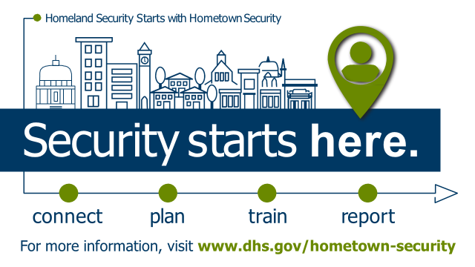](http://www.dhs.gov/hometown-security)**DHS provides free tools and resources to communities because the Department recognizes that communities are the first line of defense in keeping the public safe and secure.

The Department encourages businesses to to [Connect](https://www.dhs.gov/hometown-security#connect), [Plan](https://www.dhs.gov/hometown-security#plan), [Train](https://www.dhs.gov/hometown-security#train), and [Report](https://www.dhs.gov/hometown-security#report). Applying these four steps in advance of an incident or attack can help better prepare businesses and their employees to proactively think about the role they play in the safety and security of their businesses and communities. Download the [Tools and Resources to Help Businesses Plan, Prepare, and Protect from an Attack](https://www.dhs.gov/publication/connect-plan-train-report) Fact Sheet.

## Federal Emergency Management Agency Protecting Houses of Worship Webpage

[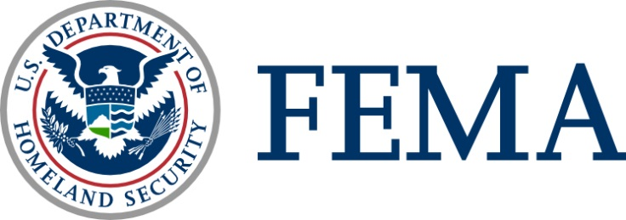](http://www.fema.gov/faith-resources)This webpage includes a collection of information from across the federal government specifically for faith-based and community leaders on:

* At-A-Glance Guide for Protecting House of Worship Venues
* Trauma, Resilience and Stress Management Resources
* Webinars
* Trainings
* Playbooks to test emergency operations plans for six hazards [**www.fema.gov/faith-resources**](http://www.fema.gov/faith-resources)

## Example Resource: United States Fire Administration Protecting Houses of Worship Against Arson Webpage

This [webpage](https://www.usfa.fema.gov/prevention/outreach/arson_prevention_houses_of_worship/) and materials was built to help community leaders increase awareness about how to prevent arson at houses of worship. Spotlight recent arson fires at houses of worship in United States.

**Federal Government Resources**

## [Department of Education: Readiness and Emergency Management for Schools (REMS) Technical Assistance Center](https://rems.ed.gov/)

[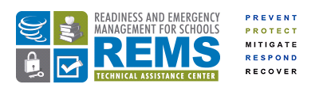](https://rems.ed.gov/)Supports schools, school districts, and institutions of higher education (IHEs), with their community partners, in the development of high-quality emergency operations plan (EOPs) and comprehensive emergency planning efforts. The REMS TA Center provides a hub of information, resources, training and services in the field of school and higher education emergency operations planning. <https://rems.ed.gov/>

## [FEMA Children and Disasters Webpage](https://www.fema.gov/children-and-disasters)

The Children and Disasters webpage reflects resources available to support the integration and implementation of children’s disaster related needs into preparedness, planning, response and recovery efforts initiated by state, local and tribal governments, as well as stakeholders responsible for the temporary care of children. <https://www.fema.gov/children-and-disasters>

## [Individuals with Disabilities and Others with Access and Functional Needs Preparedness Webpage](https://www.ready.gov/individuals-access-functional-needs)

A webpage of resources and information to ensure the needs Individuals with Disabilities and Others with Access and Functional Needs are incorporated into your preparedness efforts. <https://www.ready.gov/individuals-access-functional-needs>

**Federal Government Resources**

# Federal Government Links

* Federal Emergency Management Agency:
  + [Protecting Houses of Worship](http://www.fema.gov/faith-resources) - [www.fema.gov/faith-resources](http://www.fema.gov/faith-resources)
  + Voluntary and Faith-based Organization: [www.fema.gov/voluntary-faith-based-community-based-organizations/](http://www.fema.gov/voluntary-faith-based-community-based-organizations/)
  + [Ready Campaign](http://www.ready.gov/) - [www.ready.gov](http://www.ready.gov)
  + [Prepareathon](http://www.ready.gov/prepare) - [www.ready.gov/prepare](http://www.ready.gov/prepare)
  + [Protecting Houses of Worship Against Arson](https://www.usfa.fema.gov/prevention/outreach/arson_prevention_houses_of_worship/) - <https://www.usfa.fema.gov/prevention/outreach/arson_prevention_houses_of_worship/>
  + [Disaster Assistance](http://www.disasterassistance.gov) – [www.disasterassistance.gov](http://www.disasterassistance.gov)
* Department of Education:
  + [Readiness and Emergency Management for Schools Technical Assistance Center https://rems.ed.gov/](https://rems.ed.gov/)
* Department of Homeland Security:
  + Hometown Security Resource - <https://www.dhs.gov/hometown-security>
  + [What to Do In Case of a Bomb Threat](https://www.dhs.gov/what-to-do-bomb-threat) - <https://www.dhs.gov/what-to-do-bomb-threat>
  + [Active Shooter Preparedness Resources](https://www.dhs.gov/active-shooter-preparedness) - <https://www.dhs.gov/active-shooter-preparedness>
  + [Protective Security Advisors](https://www.dhs.gov/protective-security-advisors) - <https://www.dhs.gov/protective-security-advisors>
* Health and Human Services:
  + [SAMHSA Disaster Training and Technical Assistance Resources](https://www.samhsa.gov/dtac) - <https://www.samhsa.gov/dtac>
  + [SAMHSA Trauma-Informed Interventions](https://www.samhsa.gov/nctic/trauma-interventions) - <https://www.samhsa.gov/nctic/trauma-interventions>
  + [Center for Disease Control and Prevention (CDC) Emergency Preparedness](https://emergency.cdc.gov/) - <https://emergency.cdc.gov/>
  + [Center for Disease Control and Prevention (CDC) Coping with a Disaster or Traumatic Event](https://emergency.cdc.gov/coping/index.asp) - <https://emergency.cdc.gov/coping/index.asp>
  + [HHS Assistant Secretary of Preparedness and Response](https://www.phe.gov/preparedness/Pages/default.aspx) - <https://www.phe.gov/preparedness/Pages/default.aspx>
* Department of Justice:
  + [Protecting Houses of Worship Event Resource Guide](https://www.hsdl.org/?view&did=790107) - https://www.hsdl.org/?view&did=790107
  + [Safeguarding Houses of Worship Mobile App](https://www.justnet.org/resources/Houses_of_Worship.html) - https://www.justnet.org/resources/Houses_of_Worship.html
  + [Department of Justice Community Relations Service](https://www.justice.gov/crs) - <https://www.justice.gov/crs>
  + [FBI Office of Partnerships Active Shooter Incidents Resource Page](https://www.fbi.gov/about-us/office-of-partner-engagement/active-shooter-incidents) - <https://www.fbi.gov/about-us/office-of-partner-engagement/active-shooter-incidents>
  + [Vicarious Trauma Toolkit](https://vtt.ovc.ojp.gov/) - <https://vtt.ovc.ojp.gov/>

**State & Local Government Resources**

# Example State & Local Government Resources

## Georgia Emergency Management Agency Praise and Preparedness Program

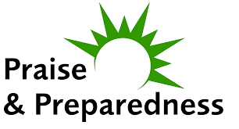Launched in January 2014, [Praise & Preparedness](http://www.praise.ga.gov/) is a statewide program from the Georgia Emergency Management Agency/Homeland Security (GEMA) that provides faith-based organizations with the tools they need to take action to prepare for a disaster. GEMA is the state agency that is responsible for emergency mitigation, preparedness, response, recovery and special events.

A key component is the Praise & Preparedness Partnership Program, which offers three ways to ensure your house of worship is prepared for unexpected events:

* **Facility Safety:** Conduct a facility safety assessment and complete or update the emergency plan for all the congregational buildings.
* **Congregant Safety:** Encourage members of the congregation to follow three simple steps to get their families and homes ready for at least 72 hours following emergencies: Prepare a kit of emergency supplies, create an emergency communications plan, and stay informed about potential threats and their appropriate responses.
* **Community Involvement:** Explore new opportunities for the congregation to become involved in community emergency disaster relief efforts, feeding and sheltering programs.

**Examples of ready-made tools include**

* 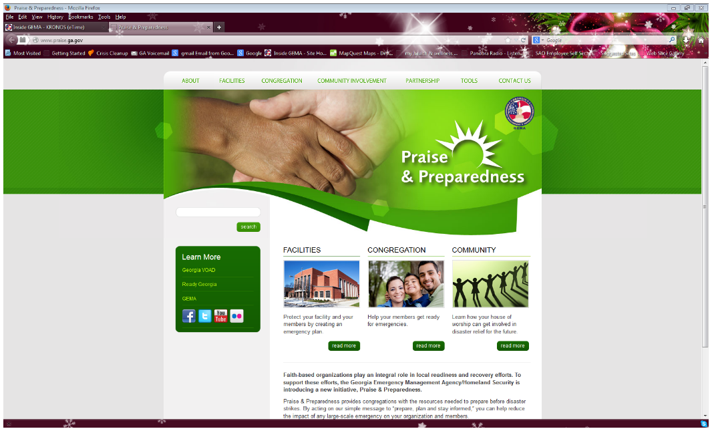[Emergency Operations Plan Template](http://www.praise.ga.gov/wp-content/uploads/2014/01/Dec-revision-of-HOW-EOP-current-copy.docx)
* [Facility Safety Assessment Checklist](http://www.praise.ga.gov/wp-content/uploads/2014/01/Revised-House-of-Worship-Facility-Safety-Assessment-Checklist.docx)
* [Human Caused Disasters Annex](http://www.praise.ga.gov/wp-content/uploads/2013/12/Human-Caused-Disasters-Annex.docx)
* [Natural Disasters Annex](http://www.praise.ga.gov/wp-content/uploads/2013/12/Natural-Disasters-Annex.docx)
* [Family Communications Plan Worksheet and Pocket Cards](http://www.praise.ga.gov/wp-content/uploads/2013/12/family-emergency-plan.pdf)
* [Disaster Relief Ministry Tables and Key](http://www.praise.ga.gov/wp-content/uploads/2015/07/Updated-Disaster-Relief-Ministry-Tables.pdf)
* [Partnership Checklist](http://www.praise.ga.gov/wp-content/uploads/2014/01/PP-certification-checklist_FINAL.pdf)
* Georgia Emergency Management Agency Praise and Preparedness Tools and Resources
  + <http://www.praise.ga.gov/tools/>

**State & Local Government Resources**

## Ready Northern Virginia Faith Developing Your Faith Organization Preparedness Plan Plug and Play Webpage

[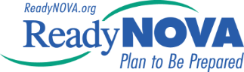](http://en.readynova.org/faith)Before you begin, please gather the necessary information to ensure your [Faith Organization Planner](http://en.readynova.org/faith) is as complete as possible. This information includes: names, addresses, and contact information of important locations such as your insurance provider; existing service providers and customers; continuity facilities; and records management.

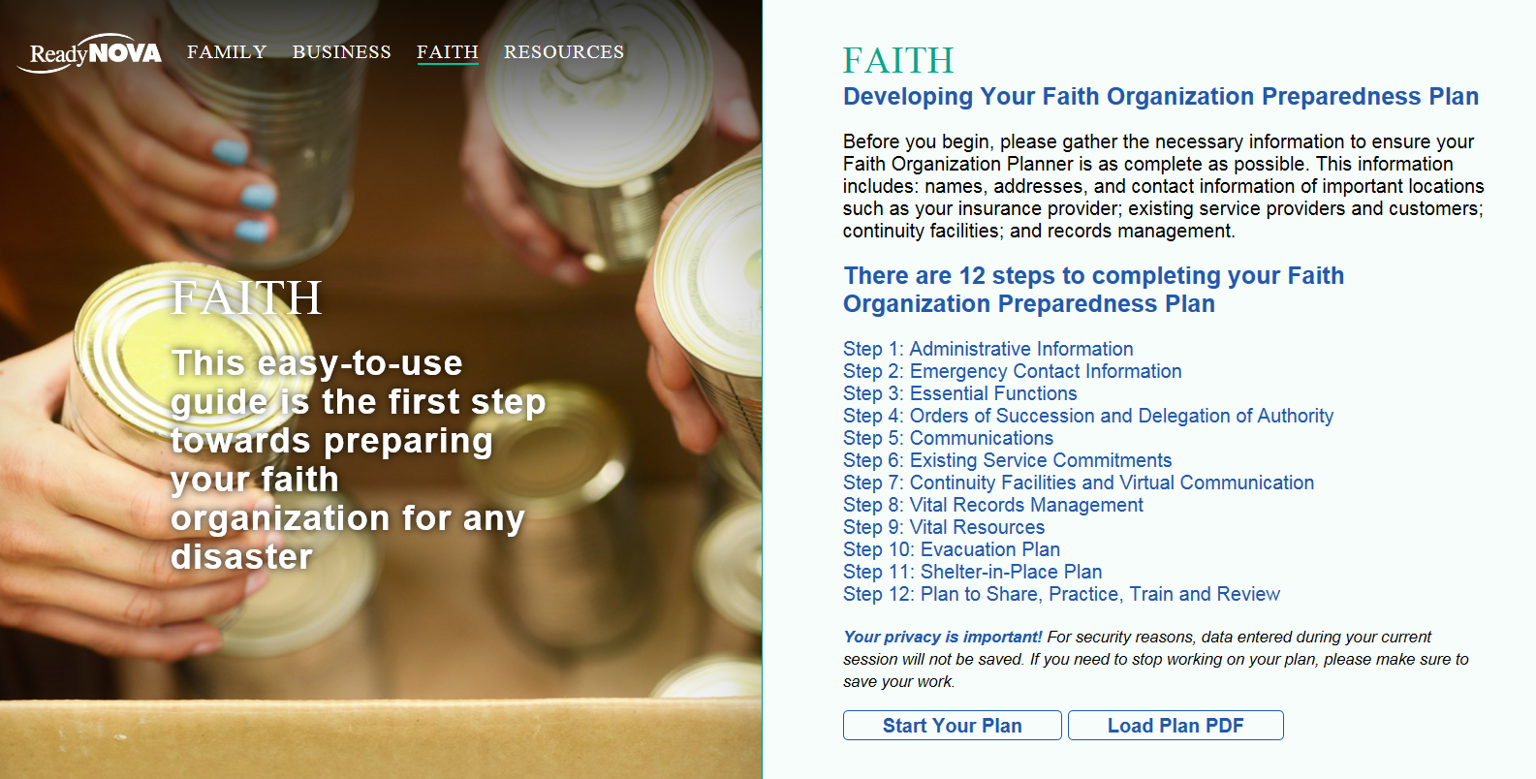There are 12 steps to completing your Faith Organization Preparedness Plan

**Your privacy is important!** For security reasons, data entered during your current session will not be saved. If you need to stop working on your plan, please make sure to save your work.

This website was prepared through a grant to the [Northern Virginia Emergency Response System (NVERS)](https://www.nvers.org/), a 501(c)3 organization, from the Federal Emergency Management Agency’s Grant Programs Directorate (FEMA/GPD) within the U.S. Department of Homeland Security. Points of view or opinions expressed in this site are those of the authors and do not necessarily represent the official position or policies of FEMA/GPD or the U.S. Department of Homeland Security.

Disclaimer: This planner is a basic continuity of operations plan provided by Northern Virginia Emergency Management organizations and is not a guarantee for surviving a disaster.

**State & Local Government Resources**

# Example State and Government Resource Links

* New York City
  + Emergency Planning Toolkit: <http://www1.nyc.gov/assets/em/downloads/pdf/Toolkit.pdf>
  + Community Emergency Plan Template: <http://www1.nyc.gov/assets/em/downloads/pdf/Template.pdf>
* Missouri Emergency Management Agency –
  + <https://adacounty.id.gov/Portals/Accem/Doc/PDF/FaithBasedEmergencyPlanTemplate22410.pdf>
  + Adopted by Ada County IN
* Iredell County Faith-based Template
  + <https://www.co.iredell.nc.us/252/Emergency-Preparedness>
* Ready Northern Virginia Faith
  + <http://en.readynova.org/faith>
* City of Los Angeles
  + [www.prep4faith.com](http://www.prep4faith.com)
* New Jersey House of Worship Webpage
  + <https://www.njhomelandsecurity.gov/faith-based-resources>
* Ready Illinois Faith-based Preparedness
  + <https://www.illinois.gov/ready/plan/Pages/Faith-based_Preparedness.aspx>
* City of Palo Alto
  + <http://www.cityofpaloalto.org/services/public_safety/emergency_preparedness/faith_communities.asp>
* Western Massachusetts Faith Based Preparedness Project
  + <http://westernmassready.org/preparedness-projects/faith/>
* City of Bloomington, Minnesota
  + <https://www.bloomingtonmn.gov/emergency-preparedness-toolkit-faith-based-organizations>
* King County, Washington
  + <http://www.kingcounty.gov/depts/health/emergency-preparedness/partnerships/Community-Resilience-Equity-Program/standards.aspx>

**National Voluntary Organizations Active in Disasters and other Non-Profit Resources**

# Example National Voluntary Organizations Active in Disasters and other Non-Profit Resources

## American Red Cross Ready Rating Materials

[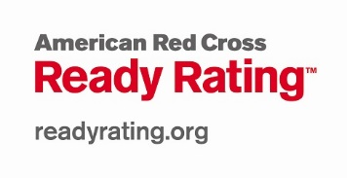](http://www.readyrating.org)The Red Cross [Ready Rating program](http://www.readyrating.org) provides a framework designed to: 1) Help businesses, organizations, and schools become prepared for emergencies; 2) Help increase the level of preparedness among individuals and families; and 3) Encourage businesses, schools and organizations to help their local communities prepare for emergencies.

This program does more than provide useful emergency preparedness information. The Ready Rating Assessments and Membership Seal make emergency preparedness measurable and visible, bringing concrete elements to an expansive framework. Additionally, the American Red Cross can provide a number of services to enhance emergency preparedness efforts that your organization undertakes.

**Membership in the Ready Rating program is simple. Here is how it works:**  
  
**1.  Join the Ready Rating Program**

* + Review the terms and conditions of membership and create an online profile.

[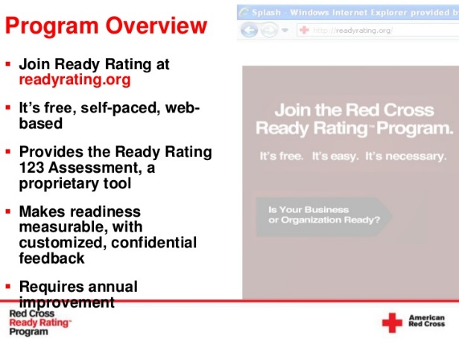](http://www.readyrating.org/)**2.  Take an Assessment**

* + This comprehensive assessment will help you to put all of your preparedness 'ducks' in a row. Your baseline assessment will be used to measure improvement at the end of the year.
  + The assessment consists of 5 sections that score emergency preparedness efforts in terms of commitment, knowledge of hazard vulnerability, emergency planning, plan implementation and community resiliency, which are the essentials of preparedness. [Learn more...](http://www.readyrating.org/HowItWorks/5EssentialStepstoPreparedness.aspx)

**3.  Create an Emergency Action Plan**

* + Use a powerful EAP template generator to create an OSHA-compliant Emergency Action plan for your organization​

**4.  Improve Your Level of Preparedness**

* + Take advantage of the detailed program guide and best practice tips available to members.
  + Conduct drills and exercises to test your plans.
  + Implement training programs, achieve certifications, etc.

**5.  Continue the Cycle of Assessing and Planning**

* + Remember, preparedness is a journey, not a destination.

Get access to hundreds of articles, videos and worksheets from the American Red Cross to help your organization stay prepared. Are you new to Ready Rating?  <http://www.readyrating.org/>

**National Voluntary Organizations Active in Disasters and other Non-Profit Resources**

## National Disaster Interfaith Network Disaster Tipsheets

This picture is an example of a mass care tip sheet developed by the National Disaster Interfaith Network, the University of Southern California and the American Red Cross.
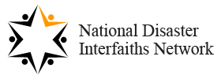 In May 2011, the [National Disaster Interfaiths Network](http://www.n-din.org/) launched its *Be A Ready Congregation* campaign.  Key to this campaign are the NDIN "**Disaster Tip Sheets for U.S. Religious Leaders**." Each Tip Sheet offers religious leaders in the U.S. all-hazards best practices and resource links about disaster mitigation, preparedness, response, and recovery – specifically of relevance to religious leaders, faith communities and faith-based organizations.

A free resource, the Tip Sheets have been developed to assist American faith communities as they seek to provide mitigation education and preparedness training or when they respond to crises and activate their congregations to coordinate volunteers, manage donations, provide mass care, attend to spiritual and mental health needs, and continue  their many religious and social services post-disaster.

NDIN Tip Sheets can be downloaded below. All rights are reserved - If our material is quoted or duplicated in other resources, please acknowledge the source. To view a Tip Sheet, click on the link: <http://www.n-din.org/>

**National Voluntary Organizations Active in Disasters and other Non-Profit Resources**

# Example National Voluntary Organizations Active in Disasters and other Non-Profit Resources Links

* Adventist Community Services Church Disaster Response Tools Webpage:
  + <http://www.communityservices.org/disaster-response-tools/>
* Lutheran Disaster Response Resources:
  + <http://www.elca.org/Resources/Lutheran-Disaster-Response>
    - Go to the general tab to access the congregational disaster preparedness guide
* North American Mission Board SEND Relief: [Disaster Ready Church Webpage](https://www.namb.net/send-relief/disaster-relief/disaster-ready-church)
  + <https://www.namb.net/send-relief/disaster-relief/disaster-ready-church>
* American Red Cross Ready Rating Program
  + <http://www.readyrating.org>
  + Active Shooter Resources: <http://www.readyrating.org/Resource-Center/Active-Shooter>
* Episcopal Disaster Relief
  + <http://www.episcopalrelief.org/press-and-resources/resource-library>
    - Found under disaster preparedness planning resources
* St. Charles County COAD
  + <http://www.communitycouncilstc.org/disasteremergency-planning-coad/faith-based-emergency-planning-initiative/faith-based-emergency-planning-resources>
* United Church of Christ Disaster Response Resources
  + <http://www.ucc.org/disaster_national-disaster-resources>
* Nazarene Disaster Response:
  + <http://www.usacanadaregion.org/basic-page/592-694-440-disaster-preparation>
* Brethren Disaster Ministries Disaster Plan Checklist:
  + <http://www.brethren.org/bdm/resources.html>
* Latter Day Saint Preparedness –
  + <https://www.lds.org/topics/emergency-preparedness>
* Presbyterian Disaster Assistance –
  + <http://pda.pcusa.org/pda/resource/prepare-to-care/>
* UMCOR Disaster Plans:
  + <http://www.umc.org/news-and-media/churches-dealing-with-disaster>
* World Renew Disaster Preparedness Resources for Churches –
  + <http://worldrenew.net/prepare-disasters>
* Disaster Resistant Communities Group – Be Ready Sunday
  + <http://www.drc-group.com/project/brs.html>
* Cook County, IL – Ready Faith Planning Guide
  + <http://www.cookcountypublichealth.org/files/pdf/emergency-preparedness/ready-faith-planning-guide-041414.pdf>
* National Disaster Interfaith Network
  + <http://www.n-din.org/>

**Private Sector & Academic Resources**

# Example Private Sector & Academic Resources

## Brotherhood Mutual

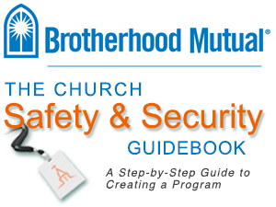Brotherhood Mutual developed this online library especially for churches and related ministries. Here, you will find articles, checklists, sample forms, and more—categorized by topic. These safety and risk management tools can help you protect your ministry and your people.

Brotherhood Mutual <http://www.brotherhoodmutual.com/index.cfm/resources/ministry-safety/disasters-emergencies-health/>

[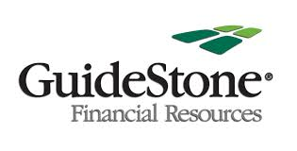](http://www.guidestonepropertycasualty.org/SafetyToolkit)

Doing all you can now to prevent problems is good risk management. Access the tips, checklists, guidebooks, articles and webinars in our Safety Toolkit to create your ministry’s personalized risk management plan.

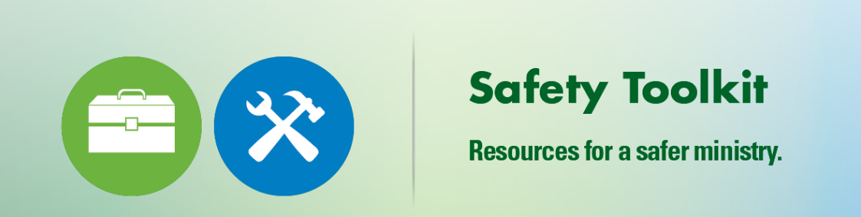

Property and liability insurance coverage provided by Brotherhood Mutual Insurance Company is subject to conditions, coverage limits, limitations and exclusions. For precise details of coverage, please refer to actual policy forms. These products are only available in states where Brotherhood Mutual Insurance Company is licensed and will be written in accordance with company underwriting rules. GuideStone is an appointed agency of Brotherhood Mutual Insurance Company in Texas and Alabama.

Guide Stone – <http://www.guidestonepropertycasualty.org/SafetyToolkit>

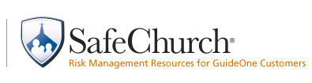

The SafeChurch Resources page provides you with access to numerous fact sheets, forms, sample policies, articles, and other documents to assist in making your church a safer place.

Guide One Insuran*ce:* <https://www.safechurch.com/Resources/Pages/default.aspx>

**Private Sector & Academic Resources**

## University of Southern California Center for Religion and Civic Culture The Religious Literacy Primer for Crises, Disasters and Public Health Emergencies

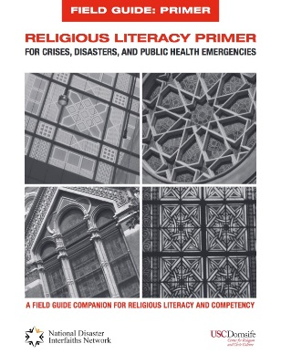The [Religious Literacy Primer](https://crcc.usc.edu/files/2015/02/Primer-HighRes.pdf) is geared toward enabling emergency managers, public health officials, first responders, volunteers, voluntary agencies and anyone involved in disaster response and recovery to understand how faith communities and emergency management intersect. It guides practitioners in their interaction with disaster-affected communities by moving beyond simplistic summaries of faith community beliefs and practices to provide guidance for physical interaction/etiquette, drawings of religious symbols, information on holidays, dietary restrictions and provision of post-disaster mass care including shelter, medical treatment and mental health care.

## Working with U.S. Faith Communities During Crises, Disasters and Public Health Emergencies: A Field Guide for Engagement, Partnerships and Religious Competency

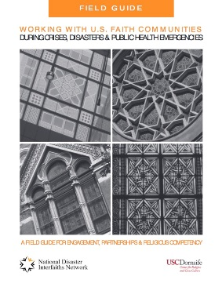

[This field guide](https://crcc.usc.edu/files/2015/02/FieldGuide-HighRes.pdf) provides detailed instructions for engaging and building sustainable and competent partnerships with faith communities throughout the entire disaster lifecycle. It is accompanied by a [Religious Literacy Primer](https://crcc.usc.edu/report/the-religious-literacy-primer-for-crises-disasters-and-public-health-emergencies/). Published by the USC Center for Religion and Civic Culture and the [National Disaster Interfaiths Network](http://www.n-din.org/), the two tools serve as accessible guides to help government agencies and non-profit organizations enhance their religious literacy and engage with faith communities during unsettled times.

## University of Southern California Center for Religion and Civic Culture Faithful Action: Faith-Based Organizations and Disaster Response and Recovery Report

[This report](https://crcc.usc.edu/faith-based-organizations-and-disaster-response-and-recovery/) details the need for increased involvement of the faith community and discusses barriers that both public agencies and faith groups face as they attempt to work together. “Faithful Action” offers recommendations for public agencies, especially the California Emergency Management Agency, as they seek to competently engage with faith communities in their disaster efforts.

## Johns Hopkins University Guided Preparedness Planning for Faith-Based Organizations

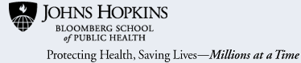In this online training, Dr. O. Lee McCabe facilitates the process of creating practical emergency preparedness plans for the purpose of improving the preparedness and response capacity of their communities.  The goal of this module and the planning process is to enhance the emergency preparedness and response capacity of communities, particularly to ensure that the mental, emotional, and spiritual health needs of at-risk citizens are met during and after catastrophic events. <http://www.jhsph.edu/research/centers-and-institutes/johns-hopkins-center-for-public-health-preparedness/training/online/guided-preparedness.html>

**Private Sector & Academic Resources**

## Wheaton College Humanitarian Disaster Institute

The Humanitarian Disaster Institute (HDI) offers resources for disaster spiritual and emotional care, disaster ministry, and for humanitarian development. These resources are intended for lay helpers, congregations and faith-based organizations, as well as for professionals in the fields of public health, mental health, and disaster management. <http://www.wheaton.edu/HDI/Resources>

## Drexel University The National Resource Center on Advancing Emergency Preparedness for Culturally Diverse Communities

Welcome to the [National Resource Center on Advancing Emergency Preparedness for Culturally Diverse Communities (“Diversity Preparedness”)](http://diversitypreparedness.org/), a web-based library of resources and information on disaster preparedness for culturally diverse communities and other at-risk populations. The planning tools, fact sheets, trainings, and other materials available through this site have been developed by academic centers, government agencies, and non-profit organizations from across the United States. They are geared for public health, healthcare, emergency management, and social service providers who work with diverse and high-risk communities.

The [National Resource Center on Advancing Emergency Preparedness for Culturally Diverse Communities Center](http://diversitypreparedness.org/) was originally developed with a grant from the Office of Minority Health, US Department of Health and Human Services. It is managed by the Center for Public Health Readiness and Communication at the Drexel University Dornsife School of Public Health. <http://diversitypreparedness.org/>

1. Source: Pew Forum on Religion & Public Life U.S. Religious Landscape Survey (2014),
2. Source: Pew Forum on Religion & Public Life U.S. Religious Landscape Survey (2014),