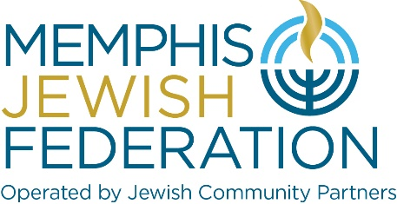

HOLOCAUST ESSAY CONTEST GUIDELINES: 2023 (Grades 9-12)

Courage and Hope: The Holocaust Through the Eyes of a Child

- Essay contest open to all high school students in TN and surrounding states.
- One entry per student.
- All entries must be typed and double-spaced in 12-point font.
- Entries may not exceed 600 words.
- Entries must include name, address, phone number, e-mail address, name of school and grade.
- Essays must be electronically submitted to HolocaustEssayMJF@gmail.com by the close of business, Monday, March 6, 2023.
- The essay should explore the following topic: Courage and Hope: The Holocaust Through the Eyes of the Child.
- When thinking about this topic, you may wish to consider the following: How did children use courage and hope during the Holocaust for survival, resilience, and the future? How did children of the Holocaust remain hopeful for a brighter future? How did children process the horrific deaths and torturous acts they witnessed? How did children survive in hiding and camps? How were children affected by their loss of education and childhood during the Holocaust? How did children resist? Could a child’s imagination take them to a beautiful place and away from the harsh reality of living through the Holocaust?
Contest entrants may use personal testimony, memoirs, diaries, historical accounts, etc. to explore the experiences of children during the Holocaust.

Suggested Resources:
Facing History and Ourselves
Yad Vashem. The World Holocaust Remembrance Center | www.yadvashem.org |

United States Holocaust Memorial Museum (ushmm.org)

https://adl.org/sites/default/files/children-of-the-holocaust-discussion-guide.pdf

www.pbs.org/auschwitz/understanding/failed.html

https://www.myjewishlearning.com/article/children-during-the-holocaust/

Books

The Daughter of Auschwitz by Tova Friedman. Tova Friedman is the Memphis Jewish Federation’s keynote speaker for the annual community – wide Yom HaShoah commemoration on Monday, April 17, 2023.
The Diary of Anne Frank

- Ideas not your own and/or quotes must be referenced.
- Judging will be based on the following criteria: originality, creativity, passion, message conveyed, connection to theme, accurate historical detail, and proper use of language.
- First Place cash prize of $250; Second Place cash prize of $125. Gift cards for Honorable Mention. Contest awards provided by the Kaethe Mela Family Memorial Fund of the Jewish Foundation of Memphis. Kaethe, her husband Paul and their 17-year-old daughter Doris, were murdered in Auschwitz.
- First Place essay will be published in the program booklet for Memphis Jewish Federation’s annual community-wide Yom HaShoah/Holocaust observance on Monday, evening, April 17, 2023. All winners will be publicly recognized at the commemoration.
- Winning essays will be published in print and digital publications.
- Please direct questions to Carrie Richardson at crichardson@jcpmemphis.org.

