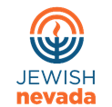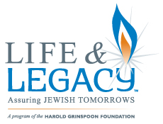

FOR IMMEDIATE RELEASE
Jewish Nevada selected by the Harold Grinspoon Foundation to launch LIFE & LEGACY™ endowment program.
Las Vegas, Nevada, September 5th, 2017
Jewish Nevada is thrilled to announce that it has been selected to partner with the Harold Grinspoon Foundation (HGF) to implement a 4-year legacy giving program, in partnership with local organizations and congregations. Together, these organizations will secure Legacy commitments to build organizational endowments and ensure a strong and vibrant Jewish community for future generations.
President & CEO of Jewish Nevada, Todd Polikoff, said, “This partnership with HGF will play an instrumental role in changing the culture of philanthropy in Nevada Jewish community. Through Life & Legacy, we will be able to not only educate our organizations and congregations on the process of building an endowment, but we will also be able to provide thousands of dollars in unrestricted incentive grants for building these endowment funds. Most importantly, we will be ensuring the future of our community for generations to come.”
The LIFE & LEGACY program will provide the infrastructure and the training for our community to fully realize the impactful role Legacy gifts can play in sustaining the future of our organizations, and, in turn, our community. This program is currently being implemented in 43 communities, has over 400 participating organizations, and has helped secure more than 14,000 legacy commitments with an estimated value of more than a half a billion dollars in future gifts to the Jewish community. For more information, or if your organization is interested in participating, please contact Jewish Nevada.

Jewish Nevada
Nevada’s Jewish Federation
www.jewishnevada.org
702.732.0556
stephanie@jewishnevada.org

