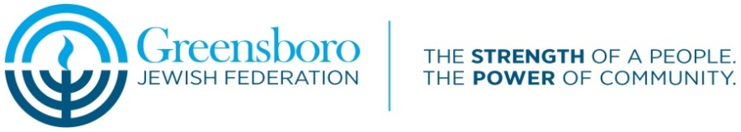

Greensboro Jewish Federation: 2016-2017 Israel Experience Grant Program

Program Objective:

The purpose of this program is to provide incentive grants to encourage rising high school juniors through college-age young adults to participate in peer group trips to Israel. The Greensboro Jewish Federation has a commitment to connecting young people to Eretz Yisrael. The Greensboro Jewish Federation is pleased to offer the following grants for programs taking place after July 1, 2016: (Please mark the one for which you are applying)

□ Program of 7-30 days duration in Israel $1800
□ Program of 31 days or longer duration in Israel $2000

Please read carefully, check off all criteria that apply to you, and sign the bottom of these procedures. Return with completed application form, Release from Liability form, and proof of registration with an approved Israel experience program. Make copies of everything. Return one copy with your application and keep one copy for your records. All parts of this application are to be completed by the applicant.

Program Criteria Check List:

 I am a rising Junior or Senior in high school, enrolled in college, or will be 23 years old or younger on the date of my trip departure.

 I have NOT been on Birthright Israel or have previously received an Israel Experience Grant from the Federation.

 I am a member of the Greensboro Jewish community and a resident of Greensboro or its environs.

 At least one of my parents or legal guardians lives in Greensboro or its environs. That family member or guardian is a member in good standing with the Greensboro Jewish Federation and has contributed to the Federation Annual Campaign this year (2016-2017).

⁪ I have scheduled my interview with David Frazier, Volunteer Coordinator, [852-5433 ext. 227 or dfrazier@shalomgreensboro.org] on __________.
[Date]

 I commit to participating in 18 hours of community service for the Greensboro Jewish Federation BEFORE the start of my Israel experience. Through this, I am intending to demonstrate a responsibility to our community. I have spoken with David Frazier, Volunteer Coordinator, 336-852-5433 x227 or dfrazier@shalomgreensboro.org, to begin my service ⁪

⁪ I will be willing to accept speaking assignments for Jewish community agencies or organizations upon my return, as well as provide an article to the ShalomGreensboro newspaper as determined by the Program Coordinator and Communications Manager.

 I will use this grant in the year it is given, for an approved, not for profit, Israel Experience program which has been approved by the Greensboro Jewish Federation. I understand that the grant may not be used in increments for more than one program and that this grant is ONE TIME ONLY.

 I have completed my application* and submitted it to:

Greensboro Jewish Federation
5509-C West Friendly Avenue
Greensboro, NC 27410
Attention: David Frazier

*Please include the following with your completed application:
⁪ Registration Form submitted to a 2016 or 2017 work or study program in Israel sponsored by a recognized national Jewish organization.
⁪ A letter of acceptance and/or proof of registration into the above-named program.
⁪ A signed form releasing the Greensboro Jewish Federation from any liability.

Please note:
- This grant will not pay for more than 50% of the program cost (trip provider fees including international
and domestic flights). Limited needs-based scholarships from the Jacke and Lottie K. Samet Fund are available through Jewish Family Services. For information, contact Betsy Gamburg at 336-852-5433 ext. 225 or by email at bgamburg@shalomgreensboro.org.

- The difference in cost between the program chosen and the grant from the Federation will be the responsibility of the individual requesting the grant. If the applicant is unable to attend the program and is entitled to a refund, the refund shall first apply to repay the Federation to the extent of the grant.

- Checks will be transmitted directly from the Federation to the sponsor of the program.

- Students attending the American Hebrew Academy whose parents are not residents of Greensboro are not eligible for this grant.

How does Birthright Israel fit in?
The Greensboro Jewish Federation, along with many other federations in North America, has made an allocation, since 1999 to support the Birthright Israel program. The Birthright Israel gift is open to all Jewish young adults, ages 18-26, post high school. The trip is open to all Jewish young adults regardless of congregational (synagogue) affiliation, community involvement, or financial wherewithal. The trip includes a round-trip ticket to Israel and 10 days of significant informational educational programming. All Hillel organizations on U.S. campuses, including North Carolina Hillel, are active partners in the Birthright Israel program. Students who have been on Birthright Israel cannot apply for the Greensboro Jewish Federation grant.

______________________________ ______________________________
Parent’s Signature Applicant’s Signature

