   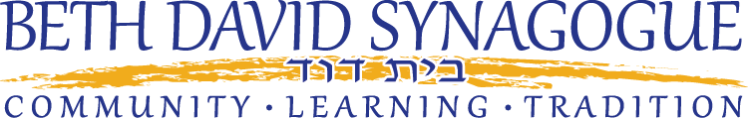

**Financial Assistance for Jewish Overnight Summer Camp—Summer 2018 for Greensboro Families**

The Jewish overnight camping experience has a meaningful and lasting impact on children, but we know that paying for it can be a daunting and confusing task. Scholarships are intended for all families, including middle income families, who find financial challenges to sending their children to camp. For information on scholarships, contact Betsy Gamburg at Jewish Family Services at (336) 852-4829, ext. 225 or bgamburg@shalomgreensboro.org. For information on the One Happy Camper program, a program that provides grants for first year campers regardless of income, contact Noam Soker (336) 852-5433 ext. 221 or [nsoker@shalomgreensboro.org](mailto:nsoker@shalomgreensboro.org) at the Greensboro Jewish Federation.

**First Year Campers**

The Greensboro Jewish Federation, Temple Emanuel, and Beth David Synagogue offer *a One Happy Camper First Year Incentive Grant* of $1250 to an approved non-profit Jewish overnight camp over 18 days long. If your child is going to a program of 12-18 days in length, such as Six Points Sports Camp, a grant of $875 is available. The approved camp list and application is at the One Happy Camper website [www.onehappycamper.org](http://www.onehappycamper.org) or *The Stanley Shavitz Camp Judaea Camper Incentive Grant Fund* provides an additional first year grant of $1000 to campers attending Camp Judaea. If you are applying for the *One Happy Camper First Year Incentive Grant*, you will automatically be considered for the *Shavitz Fund* if your child is attending Camp Judaea.

**Camp Financial Aid**

Most camps offer financial aid and will be happy to talk with you about this. Start by going to their websites to apply and follow directions there regarding financial aid. If anything is not clear, call the camp to clarify the process and make sure your request is known. Applying early is *always* a good idea.

**Jewish Family Services**

JFS provides scholarships for Greensboro area families who are challenged to meet the high cost of camp. We encourage middle income families to apply for this additional funding. The application is available on line at [www.shalomgreensboro.org](http://www.shalomgreensboro.org) or at Jewish Family Services. It’s always due by the last day of February. For JFS funds, it is necessary to apply to the camp as well for assistance. This program is administered by Betsy Gamburg at [bgamburg@shalomgreensboro.org](mailto:bgamburg@shalomgreensboro.org) or 852-4829, ext. 225.

**Assistance from Congregations**

If you are a member of a congregation, contact your Rabbi for any possible additional assistance.

*The Bradley J. Starr Campership Fund* at Temple Emanuel will have more information available at a later date.