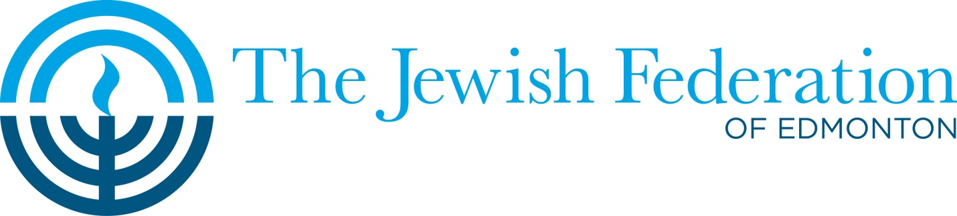

TOWN HALL MEETINGS

Come out to express your opinion on proposals for a new JCC!

Wednesday, April 15th, 7:00 pm Beth Shalom Synagogue
Lower Auditorium, 11916 Jasper Ave.

Sunday, April 26th, 2:00 pm Talmud Torah School
Gym, 6320-172 St.

Monday, April 27th, 7:00 pm Beth Israel Synagogue
Social Hall, 131 Wolf Willow Rd.

At these meetings, you will see a presentation on the work of The Jewish Federation’s Community Facilities Committee and feasibility studies prepared by professional architects on proposed plans for two possible options for a new JCC at either the Beth Israel site or the Talmud Torah site. You will have a chance to express your opinion about these scenarios in a facilitated discussion.

These events will be professionally facilitated and offer you the opportunity to engage in the planning of a new JCC for the Edmonton Jewish Community!

These discussions, along with the work already done by the committee, will form the basis
for selection of one option for Federation to pursue.

To register for these events, please phone Dani Uretsky at (780) 487-0585 or email her at daniu@edjfed.org. To participate, you must be a donor to Edmonton’s United Jewish Appeal Campaign. Pre-registration is required, so contact us now to reserve your spot. Individual participants may only attend one meeting.

