Israel Advocacy Committee

of the Jewish Federation of Collier County

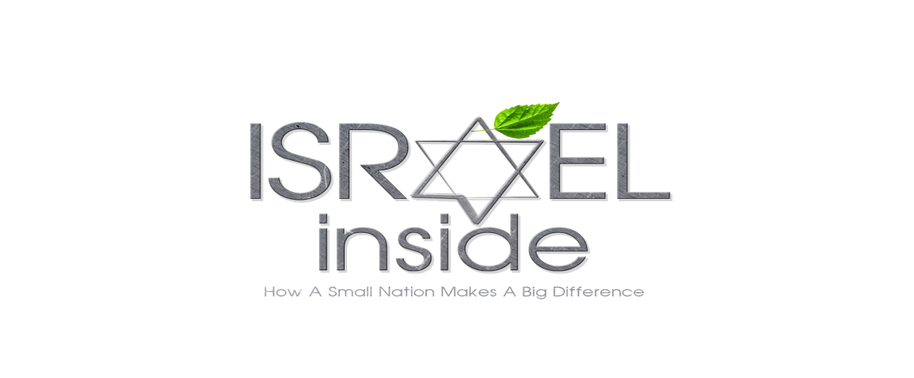invites you to watch:

**Sunday, January 8, 2017**

**Beth Tikvah at 7:00 pm**

Please join us in watching: *How A Small Nation Makes A Big Difference.* This movie explores the triumph of the human spirit. Israelis, surrounded by enemies, have turned a desert with hardly any natural resources into a flourishing and productive society.

**Cost:** $10 pp. Please send payments to: Jewish Federation of Collier County, 2500 Vanderbilt Beach Rd., Ste., 2201, Naples, FL 34109. Attn: Renee’. Payments must be received by January 3 or pay $15 at the door.

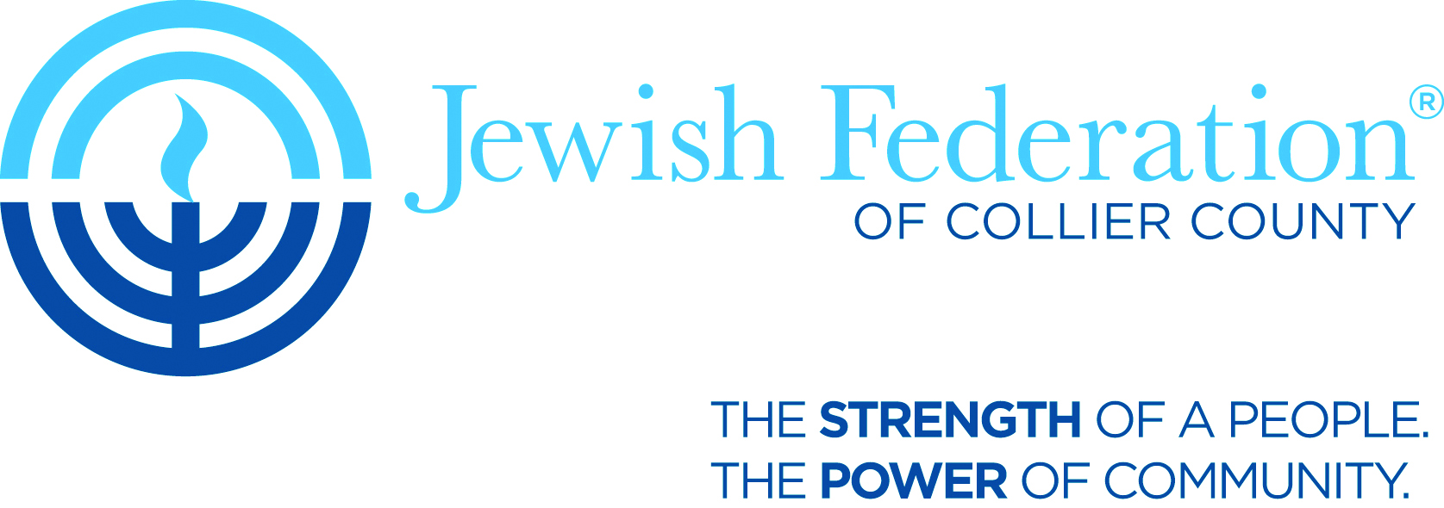**Please thank our co-sponsors:**

