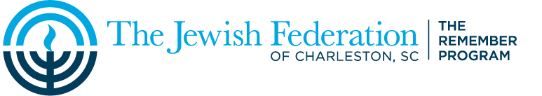

Holocaust Education Speakers Bureau

HOLOCAUST SURVIVORS

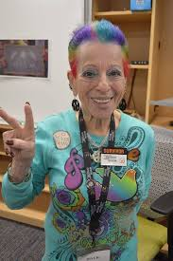
Dientje Kalisky-Adkins spent three years in terror while in hiding from 1942 to 1945. Most of the time she was locked in a closet; she was beaten, sexually abused and given little to eat. She survived the two camps where she was enslaved and was eventually reunited with her mother and father who she no longer recognized. An American soldier freed Adkins from the concentration camp and gave her a spoonful of ration and a small bite of Hershey’s chocolate. In a recent article, Diny stated, “I am full of life. I enjoy life
and I still want to live out loud.”

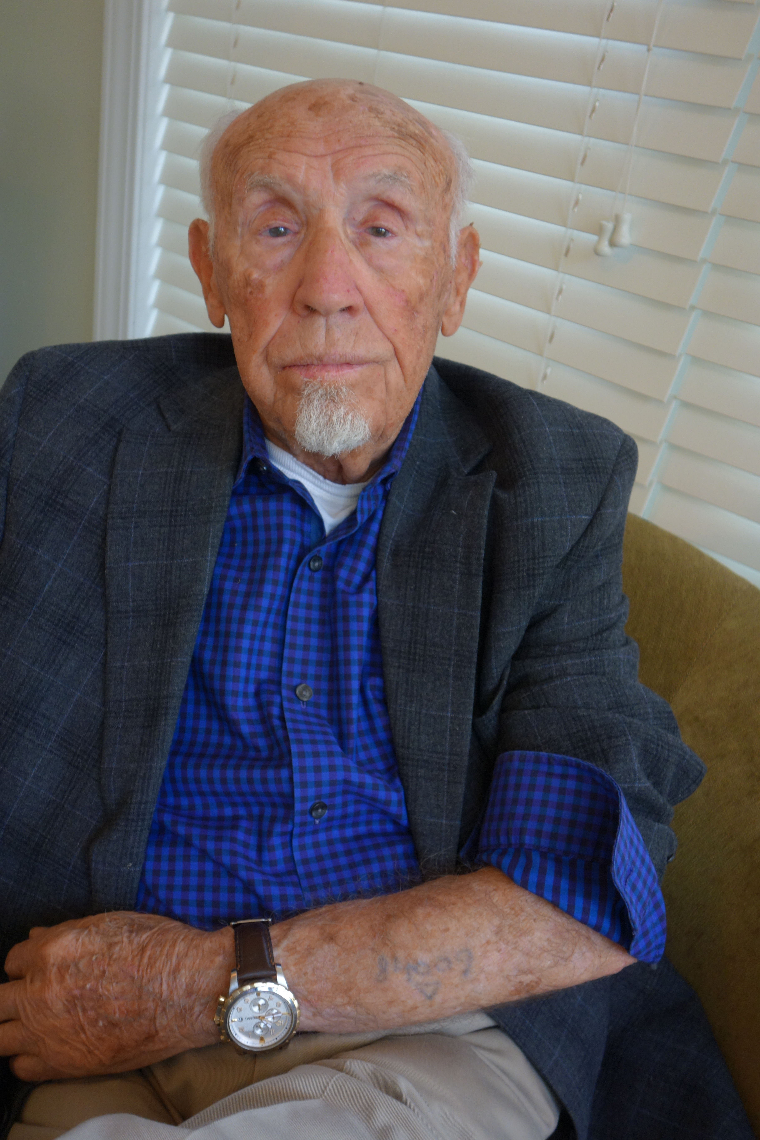
On September 1, 1939, the day the Germans invaded Poland, Joe Engel’s home town of Zakroczym was destroyed. On a transport to Auschwitz, Joe was packed in a cattle car, standing up for two and a half days with no food or water. During the Death March, he escaped from a transport train to Czechoslovakia, where he joined up with the resistance and went on missions to explode German ammunition. He was liberated by the Red Army in March 1945. A documentary was made about Joe called “To Auschwitz and Back” which can be viewed by an audience before he comes to speak.

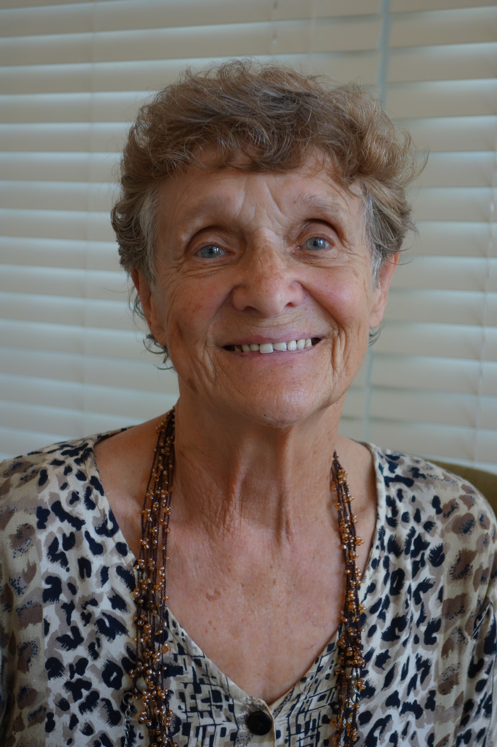
Born in Austria, Ann Field’s life changed forever in 1938. Her family was thrown out of their apartment because her mother was Jewish. After that, Ann was sent to an orphanage for half-Jewish children. Her mother was gassed and cremated in 1942 in a mental institution in Bernberg, German. Ann worked as a maid until she was liberated by the Russians in 1945. She married an American soldier and moved to the US in 1962. She has two children and four grandchildren.

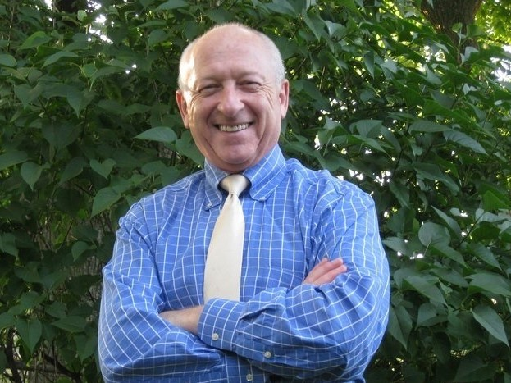
CHILDREN OF SURVIVORS
Joe Rotstein was born in the Landsberg, Germany Displaced Persons Camp, in March of 1947. Joe is the son of Holocaust survivors Mala and Leo Rotstein. Mala was a survivor of Auschwitz and Bergen-Belsen concentration camps. Leo is a
Survivor of Auschwitz. Joe and his parents immigrated to the United States in 1950, arriving through Ellis Island, and eventually settling in Chicago. Joe speaks to school groups of all ages recounting the story of his parents' Holocaust survival. He stresses tolerance of all people in his discussions as well as human rights. Joe feels he honors the memory of his parents through his presentations.

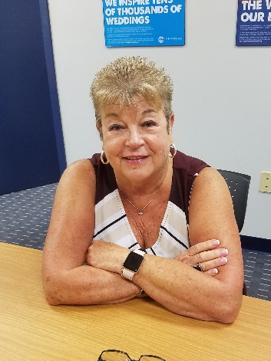
Reggie Guigui - Reggie Guigui was born in Germany, the daughter of survivors from Poland and Czechoslovakia. She grew up in Cincinnati, Ohio, a teacher by profession, and started lecturing when she realized some students didn’t know what the Holocaust was. She has been involved in Holocaust education in Cincinnati before moving to Charleston and works with the Remember Program in Charleston. She has been lecturing since 1990 sharing her parents’ stories using photographs that survived the war.

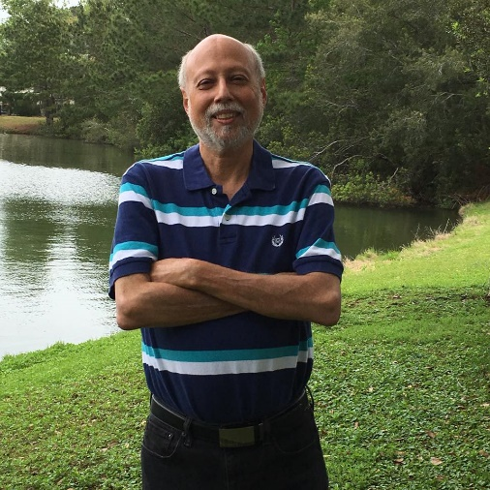
Fred Volkman –Fred is a retired physician originally from Chicago. His parents were Holocaust survivors who lived in Chicago after immigrating to the United States. They belonged to the Janusz Korczak B’nai Brith lodge, made up entirely of Holocaust survivors. His mother escaped a small Polish ghetto early in the war. She then went into hiding with her uncle, moving from place to place until the war ended. His father briefly worked with the Polish underground, but was captured and placed in various work camps until he was transferred to the Flossenburg concentration for the remainder of the war. Their entire families were wiped out by the Nazis. His mother passed away ten years ago and his father passed three years ago, at the age of 94. He has been an active member of Charleston’s Remember Committee for several years, but only this year was able to take an amazing journey to Israel, hiking through Israel’s major cities, religious and historical sites; including Yad Vashem.

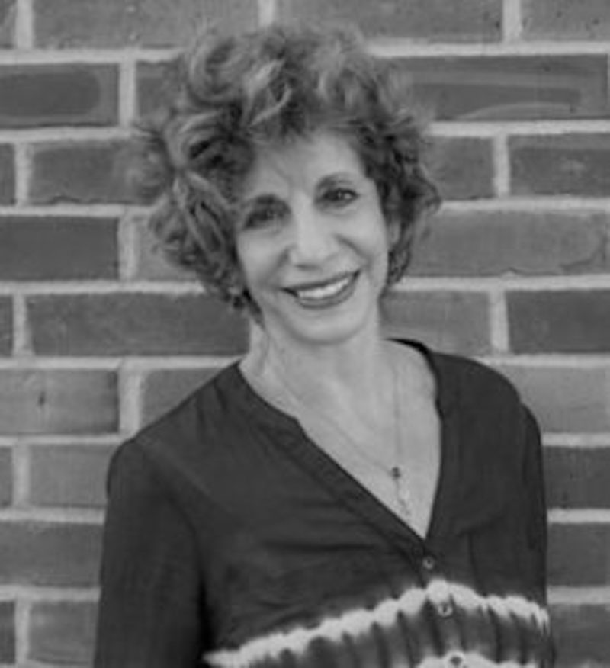
Sandra Brett is the daughter of two survivors. Her mother survived the Lodz Ghetto, Auschwitz, and Mathausen, and her father survived ghettos and work camps in Lithuania before escaping to join a group of Jewish partisans. As a practicing artist, Brett's special interest is art as it relates to the Holocaust. She has lectured extensively about her parents' experiences during the war as well as art of the Holocaust.

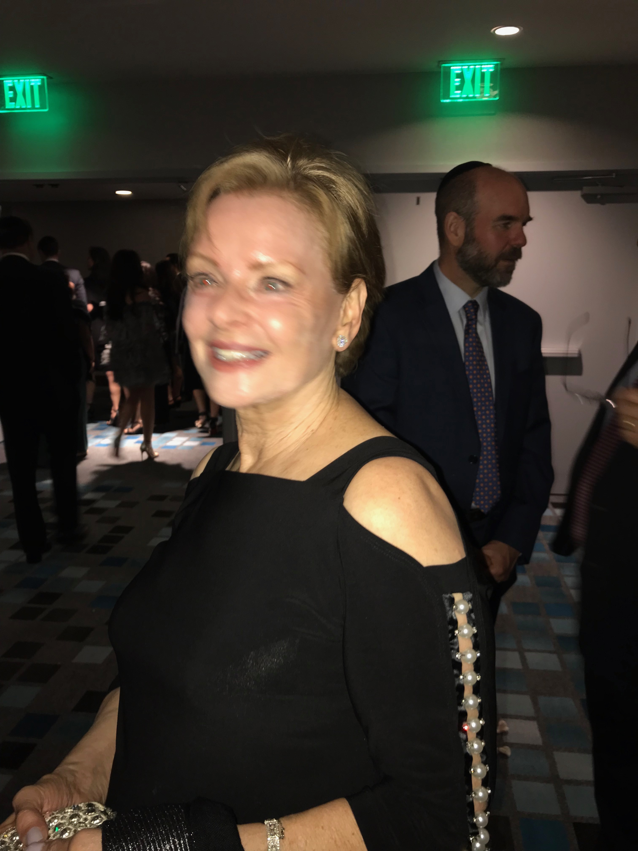
Shirley Mills is the daughter of two Holocaust survivors. Born in a refugee camp in Italy, raised in Israel, Shirley came to the States as a young teen. Her parents ‘ story is of pain hope, and amazing courage and resilience. In their memory, she wants to share their story because humanity has not learned from the past.

TEACHER TRAINING
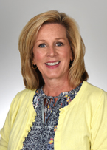
Theresa Stephens, PhD, MSN, RN, CNE is an Associate Professor in the College of Nursing at MUSC with primary teaching responsibilities in the RN-BSN program. Dr. Stephens’ research explores the concept of resilience in healthcare professionals/students as a tool for personal growth and well-being, as well as a means of improving patient outcomes. Dr. Stephens works closely with several Holocaust organizations and is an advisory board member for the Vantage Point Foundation, a non-profit organization supporting post-9/11 veterans. She can provide the following training: “Holocaust Whispers: Lessons in Resilience. ”This is the title for BOTH a course and a presentation. The course itself is one developed for graduate students (3 credit hours), but could be adapted for high school or undergraduate students. The presentation is an overview of Dr. Stephen’s research in resilience and how she has used the stories of Holocaust survivors to teach nursing students to become more resilient. Stephens has adapted her presentations for several groups (middle school, high school, undergraduate students, graduate students, teachers/faculty, administrators, youth pastors, counselors, etc. Theresa Stephens can be contacted directly at stephent@musc.edu

