2018 BARISH SHABBAT LIMMUD SCHOLARS

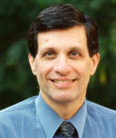
Rabbi Miles B. Cohen, hosted by Congregation Or Ami
Rabbi Miles B. Cohen was ordained by the Jewish Theological Seminary of America in 1974. For over twenty years, he worked in curriculum development at the Melton Research Center at JTS, and was a lecturer in the Rabbinical School teaching students who were preparing to become rabbis, cantors, educators, and lay leaders. Rabbi Cohen is a recognized authority on aspects of the biblical Mesorah and has published and delivered academic papers on those subjects. He lectures and conducts workshops on topics related to synagogue practice. Rabbi Cohen has created guides and interactive software for learning to read Torah, haftarah, and megillot, as well as guides for nusach skills and Hebrew grammar. He is co-author of Luach Hashanah, an annual guide to ritual practice in the home and synagogue.

Yom Limmud: “The Aleppo Codex: What is It and What Can We Learn from It?”

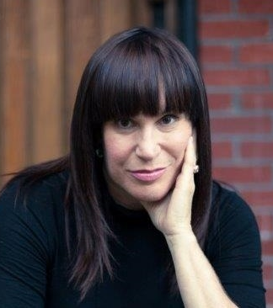
Adrienne Gold, hosted by The Bellaire Jewish Center
Toronto-based Adrienne Gold, who comes from a secular background, speaks movingly about her transition from a career in television and the fashion industry to a life of observant Judaism. She was a fixture on Canadian television for almost two decades, both as host of her own daily fashion and beauty program, and as a regular contributor on scores of others. Her direct, no holds barred approach and her disarming humor won her a large and loyal viewership. About 18 years ago, Adrienne’s family began the journey to re-claim their Jewish spiritual roots, and she found herself more interested in discussing matters of Jewish substance. She left television and today is an international lecturer and a Trip and Education Leader for the Jewish Women’s Renaissance Project Israel, living half the year in Israel.

Yom Limmud: “Commitment: The Courage to Live and Love Without an Exit Strategy”

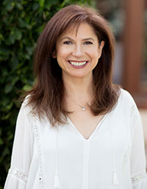
Rabbi Naomi Levy, hosted by Congregation Beth Yeshurun
Rabbi Naomi Levy, founder and spiritual leader of Nashuva, a groundbreaking Jewish outreach organization based in Los Angeles, is a unique and passionate voice in the contemporary Jewish world. Through Nashuva, Rabbi Levy has been involved in drawing hundreds of unaffiliated Jews back to a Judaism that is soulful, committed to social justice, meaningful, relevant and fun. The Jewish Forward recognized Rabbi Levy as one of the 50 most influential Jewish leaders in the nation. Newsweek Magazine named her in its “Top 50 Rabbis in America” list. Rabbi Levy was in the first class of women to enter the Jewish Theological Seminary’s rabbinical school. She became the first female Conservative rabbi to head a pulpit on the West Coast.

Yom Limmud: “Einstein, the Soul and the Search for the Meaning of Life”

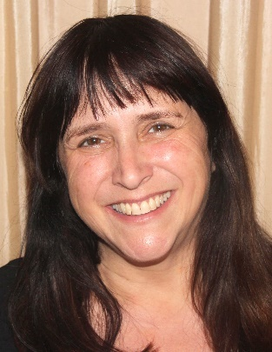
Rabbi Susan Silverman, hosted by Congregation Beth Israel
Rabbi Susan Silverman is the sister of Laura, an actress and writer, Jodyne (Speyer), a writer, and Sarah, an actress, writer and comedian. Susan’s route to becoming a rabbi was an unusual one. Growing up as one of few Jews and few Democrats in her NH schools, Susan thought that being Jewish meant two things: you were politically liberal and had Hanukkah instead of Christmas. She met her now husband, Yosef, in the anti-Apartheid movement at BU and was taken by the language he had at his disposal to describe the movement. Where Susan knew that “racism and oppression were bad,” Yosef spoke in terms of eternal values like tzelem elohim – that everyone is made in God’s image. She was hooked on him – and Judaism. Today Susan’s rabbinic work includes activism on behalf of asylum seekers in Israel, advocating for liberal Judaism, and promoting adoption. She is a founder of KAMOCHA: A Jewish Response to Refugees, on the Board of Directors of Women of the Wall, on the International Council of The New Israel Fund and the Founding Director of Second Nurture: Every Child Deserves a Family – And a Community. Susan is currently on a multi-media book tour in the U.S. with her memoir, Casting Lots: Creating a Family in a Beautiful, Broken World (Da Capo Press)

Yom Limmud: “Casting Lots: Creating a Family in a Beautiful, Broken World”

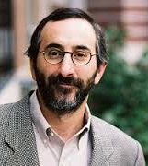
Dr. Benjamin D. Sommer, hosted by Congregation Brith Shalom
Benjamin D. Sommer is Professor of Bible at the Jewish Theological Seminary of America. Previously, he was the Director of the Crown Family Center for Jewish Studies at Northwestern University, where he taught from 1994 through 2008. He has been a visiting faculty member at the Hebrew University, the Shalom Hartman Institute, the University of Chicago, and Brite Divinity School of Texas Christian University. Dr. Sommer has been a Fellow of the Tikvah Center for Law and Jewish Civilization at the New York University Law School, the Israel Institute for Advanced Studies, the Yad Hanadiv Foundation, and the American Council of Learned Societies. He frequently teaches rabbinic and lay groups in the United States and Israel. Dr. Sommer is the author of several books including A Prophet Reads Scripture: Allusion in Isaiah 40-66 (Stanford University Press, 1998), The Bodies of God and the World of Ancient Israel (Cambridge University Press, 2009), and Revelation and Authority: Sinai in Jewish Scripture and Tradition (Yale University Press, 2015.) An overarching concern of Dr. Sommer's scholarship involves the close and manifold relationships between biblical thought and later Jewish theology, or, to use the Hebrew phrasing, between Torah shebiktav and Torah shebe'al peh. His books have won multiple awards from scholarly organizations.

Yom Limmud: “Two Israelites, Three Opinions: Diversity in the Bible”

2018 SHIRLEY BARISH EDUCATION ENRICHMENT SCHOLAR

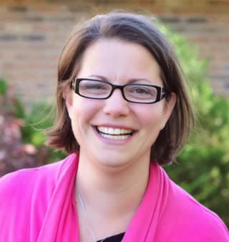
Jenna Kalkman-Turner
Jenna Kalkman-Turner is the Director of Early Childhood Professional Learning at the Community Foundation of Jewish Education in Chicago. Her passion for the field of early childhood learning began when she graduated from the University of Iowa with a B.A. in Elementary Education and a specialization in early childhood education. After two years in a campus-based program, Jenna moved back to the Chicago area where she spent the next seventeen school years at Moriah Early Childhood Center in Deerfield, Illinois, eventually becoming its Associate Director. In 2013 she transitioned to become the Director of the Gan Ami Early Childhood Center at the Harry and Rose Samson JCC in Milwaukee, Wisconsin. Jenna’s journey and work in the field has inspired her passion for working with educators. She has been a presenter at multiple CAJE, NAEYC, and NJECN conferences. Jenna is highly sought after as a consultant on environment, communication and implementation of curriculum in early childhood programs.

