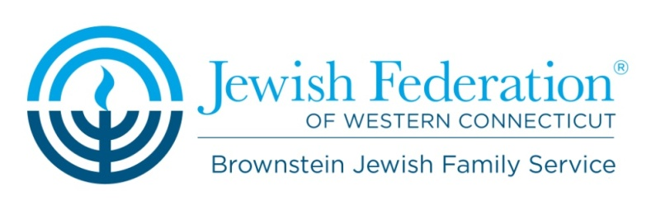

Brownstein Jewish Family Service

Winter 2017

Call 203-267-3177 for any questions or additional information

Finding Your New Normal: Life after Loss
Thursdays at 3:30 pm
A free, six-week group for any adult who is coping with the death of a parent, spouse, sibling, other family member or friend. Led by Jenny Casey, LCSW of Regional Hospice and Palliative Care, this non-denominational, bereavement group is supportive in nature, providing a safe environment for sharing with others who have also been touched by loss.

The size of the group is limited and registration is required. To register, call 203-702-9152 or email jdenicola@regionalhospicect.org.

Free Social Service Screenings for SNAP (food stamps)
Thursdays, March 16th, April 20th & May 18th from 9:00-1:00 pm
Offerings confidential screenings for individuals and families who may need assistance affording the cost of food at supermarkets, grocery stores and farmers’ markets. Screenings are completed by Staywell Health Center staff. To register call, Staywell Health Center at 203-756-8021 X 3116.

Alzheimer’s Support Group Thursdays March 9th, April 13th & May 11th at 10:30 a.m.
This open, friendly and on-going group for families, caregivers and friends is led by Patty Gibbs, volunteer with the Alzheimer’s Association of Connecticut. Drop-ins are welcome!

Love, Life & Friendship
Thursdays March 16th , April 20th, May 11 & June 8 from 2:00-3:00pm
This ongoing monthly workshop is designed for individuals who have lost a spouse or significant other either through death or divorce and are looking to educate themselves on topics related to enhancing social life and entering the “dating world.” Expect to have fun, laugh and create a network of friends with whom you can enjoy life. RSVP by the Tuesday prior at 203-267-3177 X 340.

Food Resource & Education Seminar
Tuesdays February 28th, March 7th, April 4th, May 9th & June 13th
This six part seminar is open to community members over the ages of 65 and will be held at the Jewish Federation of Western Connecticut. The seminar is intended to educate individuals on how to eat healthy and remain active on a budget. New topics will be introduced at each session along with information on how to access community food resources and how to get help if you are in need of additional food or groceries.

“Time Out” A Yoga Series for the Busy Parent
Fridays, from 9:30-10:30am
Brownstein Jewish Family Service seeks to improve the physical and emotional well-being of our community through a variety of programs and services. This year we are excited to do just that through a new health and wellness program geared towards busy moms and dads alike! This program is a 6 week yoga series that will provide every busy parent the opportunity to take a “time out” through yoga. Expect to relax, de-stress, increase flexibility and positively impact your physical and emotional self!

This series is appropriate for the newest yogi to the most experienced. Classes will run for approximately 60 minutes and consist of physical yoga practice and meditation. Cost $5.00 per class $20 for the series. Please RSVP by the Thursday before class 203-267-3177X 340.

See other side for more programs!

Brownstein Jewish Family Service

Winter 2017

Youth Mental Health First-Aid Training
March 21st and March 2nd, from 4:00-8:00 Pm
Youth Mental Health First Aid is designed to teach parents, family members, caregivers, teachers, school staff, peers, neighbors, health and human services workers, and other caring citizens how to help an adolescent (age 12-18) who is experiencing a mental health or addictions challenge or is in crisis. Youth Mental Health First Aid is primarily designed for adults who regularly interact with young people. The course introduces common mental health challenges for youth, reviews typical adolescent development, and teaches a 5-step action plan for how to help young people in both crisis and non-crisis situations. Topics covered include anxiety, depression, substance use, disorders in which psychosis may occur, disruptive behavior disorders (including AD/HD), and eating disorders. To RSVP, contact ymhfa@edadvance.org or 860-567-0863

Free Information and Referrals
Please contact Meredith Hettler, Brownstein Jewish Family Services Program Manager at 203-267-3177 x 310 or email mhettler@jfed.net. All programs are held at the Jewish Federation of Western CT, 444 Main St. North in Southbury.

