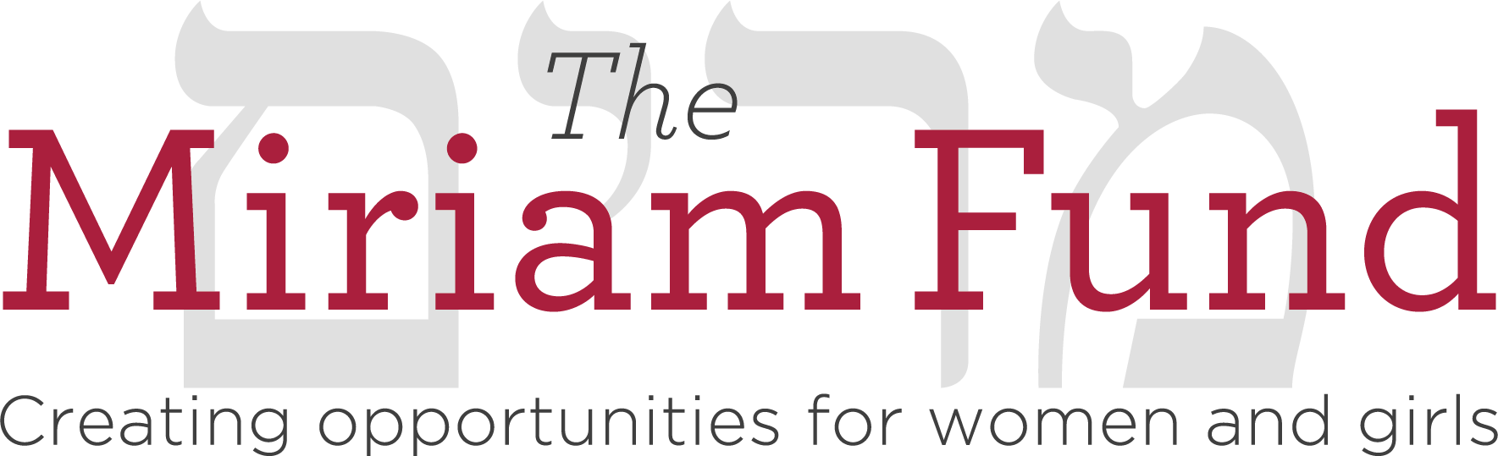

THE MIRIAM FUND GRANT CYCLE
FY23 Timeline (for 2023–24 Grant Term)

Monday, August 1, 2022 LOI stage opens.
Wednesday, August 31, 2022 LOIs are due.
Tuesday, November 15, 2022 Organizations will be notified whether they will be asked to submit a full proposal.
Wednesday, January 11, 2023 Applications are due.
Feb. 28-March 2, 2023 Grant Subcommittees meet for initial discussion of proposals.
March 6-22, 2023 Site visits (virtual or in-person) are conducted.
March 28-30, 2023 Grant Subcommittees meet to make final decisions.
May 2023 Grant decisions are announced.
August 2023 Grantees receive first half of grant funds.
December 2023 Grantees’ mid-year evaluations are due.
February 2024 Grantees receive second half of grant funds.
Friday, June 28, 2024 Grantees’ end-of-year evaluations are due

