CJP’s Young Adult Community Grant Program:

How-To Guide for Online Registration

Follow this step-by-step and screen shot guide to get you ready to start working with our **new and easy to use** online application portal

**Log on to this website:** <http://cjp.spectrumportal.net/Accounts/Logon/SearchGrants/ProposalApplicants>

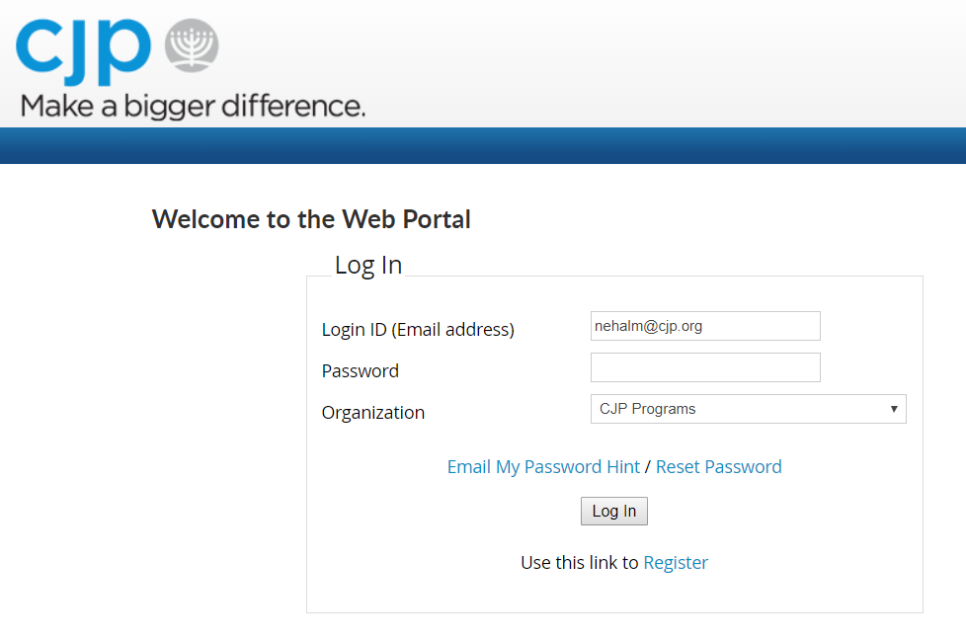

**Since it’s your first time visiting the site, you’ll need to click the register link below the Log In button. Registration is quick and easy – it shouldn’t take much time to fill out the form!**

**Have you applied for a Young Adult Community Grant before? Start here!**

* **At “Portal Access”, please choose Grant Applicant**
* **Next you’ll search for the organization you want to submit a grant for**
* 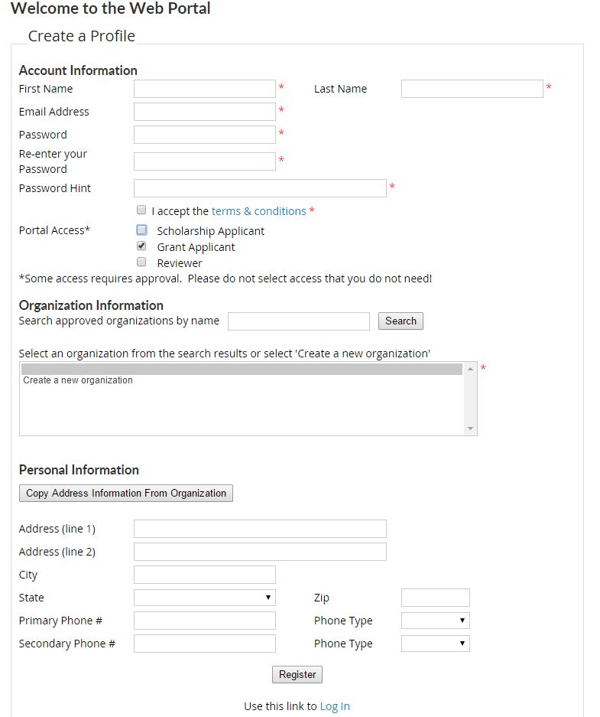**If your organization does not come up when you search, please jump to page 6 to register a NEW organization**

* = Mandatory fields

**\*You can update your address if need be under Personal Information. Otherwise – you can copy it with the button and it will also auto fill in your application!\***

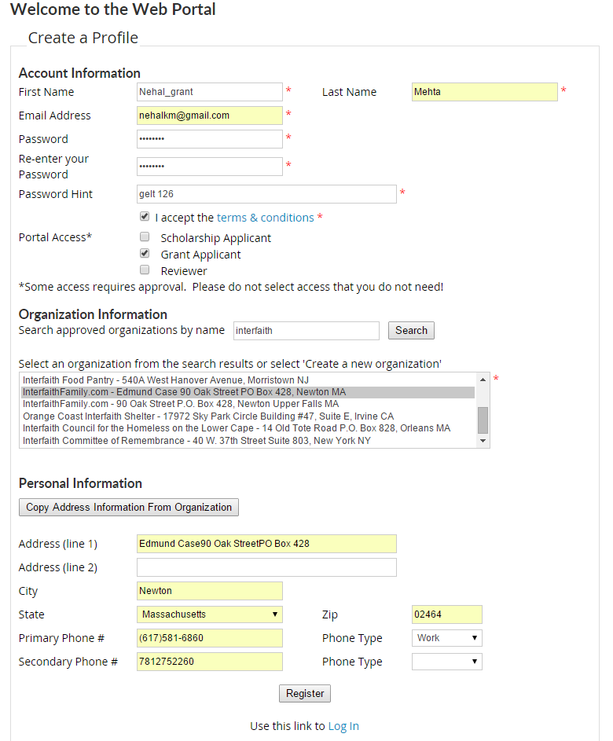

**Once you click the “register button”, you’ll see the following pop-up:**

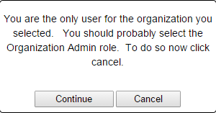

**\*We are still working on updating this language and apologize for the confusion!\***

**Please feel free to click continue and we will follow up with you in terms of assigning the Organization Admin role.**

**If you are a new organization or idea, this is where your detailed instructions come in handy!**

* **You’ll still create a log-in and check off “Grant Applicant”**
* 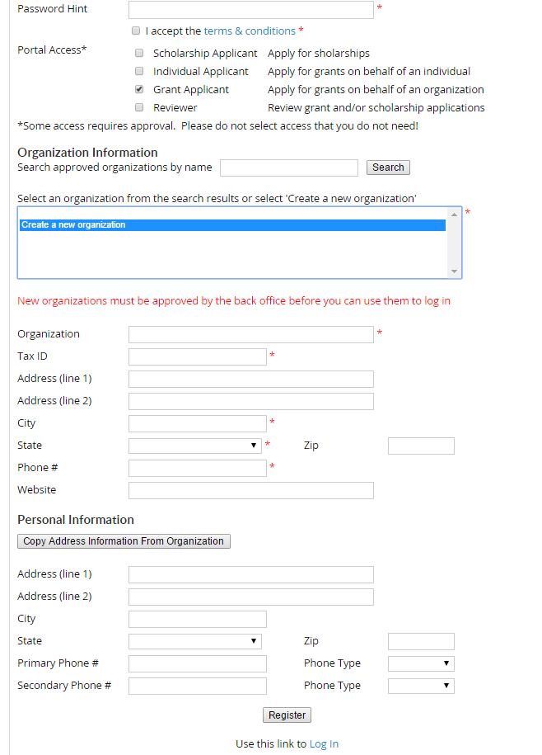**Next – click on “Create a new organization” (see below)**

**Fill out your organization’s details and hit save.**

**We recognize you may not have a tax ID # and will be using a fiscal sponsor. If this is the case, please type in 12-3456789 as a substitute. In the application, you’ll have a chance to list your fiscal sponsor and their information!**

**When you’re done, click “Register” and you will get the following pop up:**

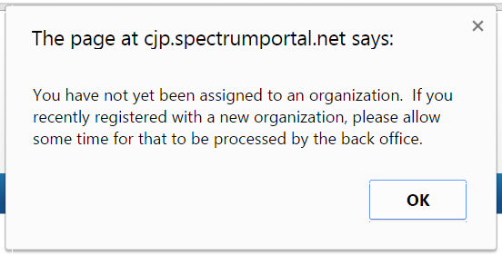

**Sorry for the formal pop up, but CJP’s Young Adult team needs a little time to process the new organization. But once that has been completed, we will be sure to notify you right away so you can start applying for grants!**