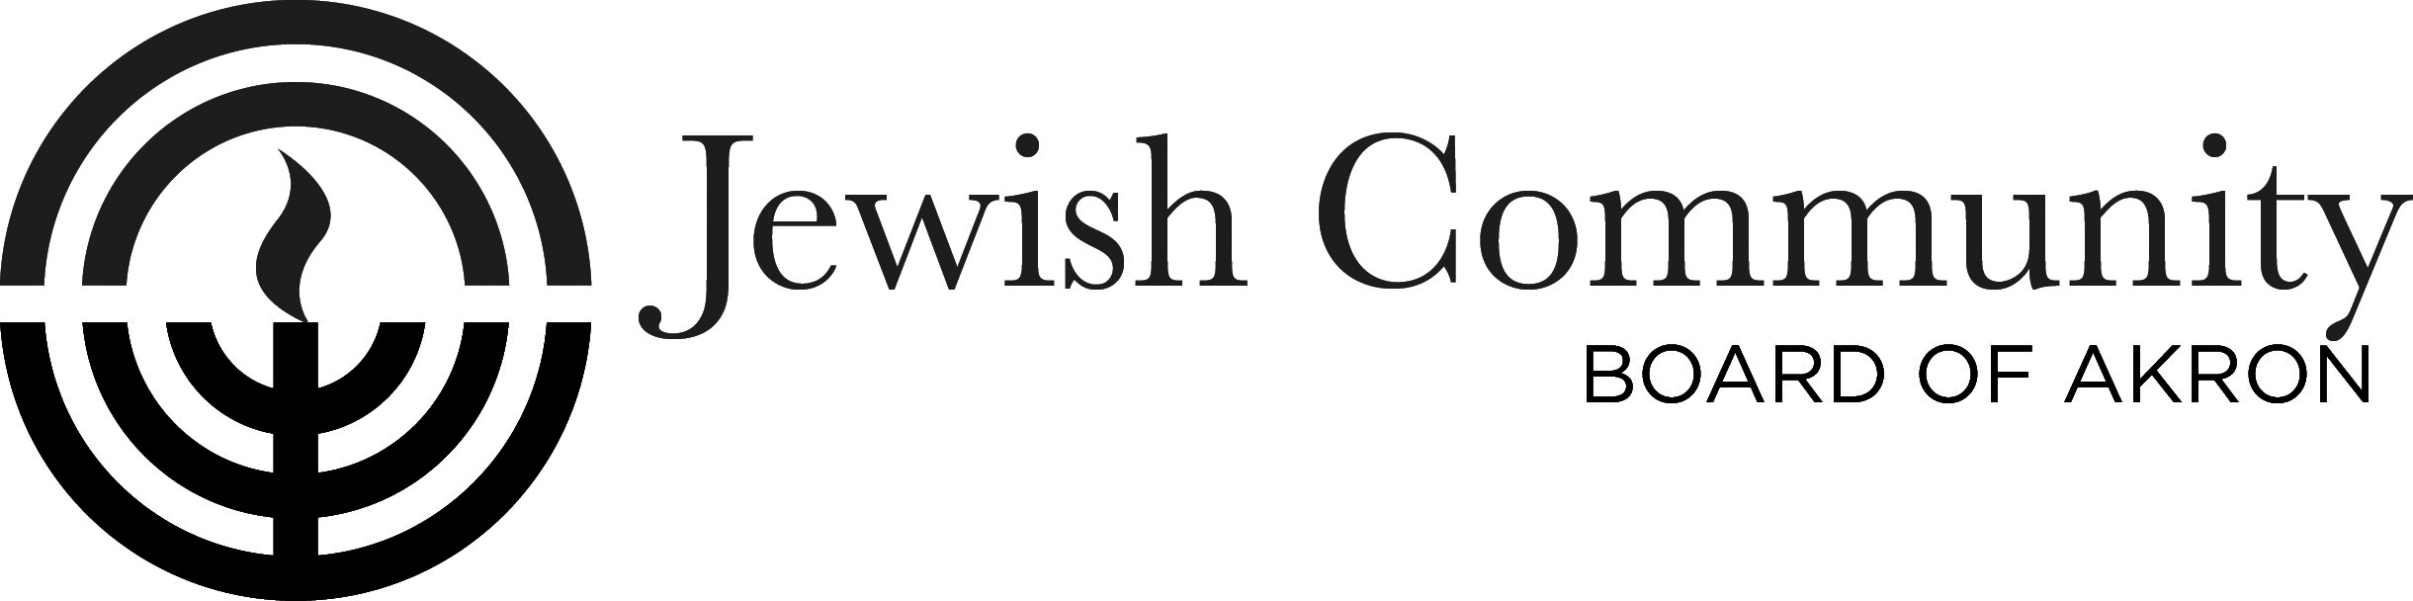
Invites you to enroll in

Encountering Jewish Culture: through Stories, Poetry & Art: 2019 – Part II

Jewish American Literature -
Selected stories thru time -continued

We will read and discuss new selections of Jewish American Writing from 350 years. Our book spans from 1645 to the present, including —fiction, poetry, drama, essays, letters, editorials, journals. Do Jews writing in America make up a literary tradition? If so, what defines that tradition? Invite friends to join in discussions; or give contact info to Esther Hexter. Everyone is welcome to join our conversation. No prerequisite, only desire to learn.

With
Esther Cohen Hexter

Time: 6 Wednesdays in a Row, 11:00 AM-12:45 PM
April 24, May 1, 8, 15, 22 & 29, 2019

Location: Schultz Campus for Jewish Life in Shaw JCC
750 White Pond Dr., Akron, OH 44320

Text: Jewish American Literature: A Norton Anthology, edited by Jules Chametzky, John Felstiner, Hilene Flanzbaum & Kathryn Hellerstein [Students provide own or borrow book]

Fee: Class: $25.00

Register: By mail or in person: Registration deadline: April 16, 2019

Courtesy of grant from: Edward I. Abramson Program Fund, Jewish Community Board of Akron
-----------------------------------------------------------------------------------------------------------------------------
Jewish American Literature - Registration Form

Name__________________________________________ Home Phone_________________________

Address_________________________________________City/State/Zip________________________

Work or Cell Phone _______________________E-mail ______________________________________

Minimum registration required. [Use own or borrow book.] Class Fee: $25. Registration Deadline- April 16, 2019
Register by Mail or in person. Amt. Enclosed ____ payable to: “JCBA”, to: JCBA, c/o Jewish Stories, 750 White Pond Dr., Akron 44320 Questions: eshexter@juno.com or 330-836-0777

