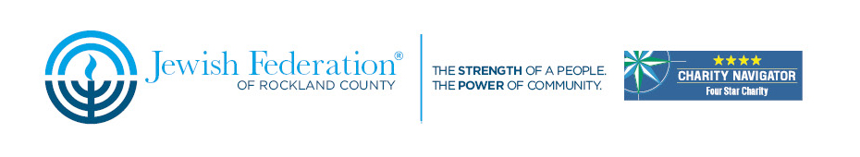
Jewish Federation of Rockland County
Mission to Morocco

Estimated Cost for Land and Air (direct flights) $4,290 per person*. Single supplement, $530.
There is a minimum gift of $613 per person to the 2015 Federation Annual Campaign
This budget is based on estimated rates since we do not have final rates for 2015 at this time. Final rates should be available from the hotels in late July 2014. Flight rates are estimated at $1,110 and subject to change. Airport taxes & fuel surcharges are included.
Rates are per person based on double occupancy and a minimum of 15 full paying participants.
Price Includes
7 nights’ accommodation (including breakfast) as shown below
Free air based on $1,110 per ticket and includes airport taxes & fuel surcharges *
7 days of touring in a luxury, air-conditioned bus with licensed, English speaking local tour guide
Da’at tour educator accompanying the group from arrival to departure
Group transfer and assistance to and from the airport
All site entrance fees and program fees as per itinerary
Meals as shown below
Portage at the airport and hotels
Mineral water on the bus throughout
Not included-
Tips, meals not included as per itinerary, single supplement, incidentals
*once hotel and flight prices have been confirmed, we will have a final price

