Global Day of Jewish Learning
Sunday, December 8, 2019
Rockland Jewish Community Campus, 450 W Nyack Road, West Nyack NY
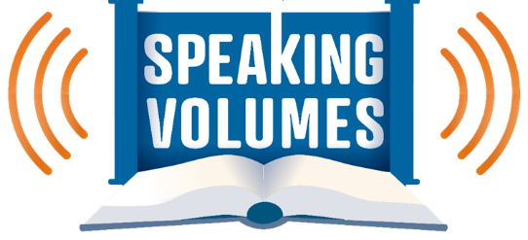
From ancient arguments to modern meanings, from raising our voices to remaining silent, explore how and why words matter.

9:30 am Sign-in & refreshments
10-11 am Session One (pick one of the following)
1. Names: Meaning and Memory. Names are words we use — for ourselves and for others — to demonstrate the nature of our relationships and how we view the world. We will look at texts that explore how names connect us with meanings and memories. With Rabbi Dan Pernick, Beth Am Temple.
2. Moses: Not a Man of Words? Moses is remembered for his many teachings, but did you know that Moses did not consider himself a man of words? We will take a closer look at the tension between Moses’ actions and his words, and what this teaches us about leadership. With Rabbi Benjamin Sharff, Reform Temple of Rockland.
3. Hurtful Words. What can Jewish texts teach us about the ways our words can cause harm? In this unit, we will explore how the words we choose and use can affect those around us, whether or not we intend for those words to wound. With Rabbi Brian Leiken, Temple Beth Sholom.
4. The Silence of Aaron. Silence can be a kind of speech, and what is unsaid is often as important as what is said. In the Bible, Aaron’s response to tragedy is summed up in two words: “Vayidom Aharon — and Aaron was silent”. What meanings does his silence hold? With Rabbi Joshua Finkelstein, Montebello Jewish Center.

11:15 am-12:15 pm Session Two (pick one of the following)
1. Hurling Words Towards Heaven: Hannah’s Prayer. The Talmud holds up Hannah as a model for how to pray. Though she appears in the Bible only briefly, she makes a lasting impression. What can we learn from Hannah’s prayer about how we converse with the Divine? With Rabbi Paul Kurland, Nanuet Hebrew Center
2. Not One Empty Word. The Bible is a book that speaks volumes, through the ongoing act of interpretation known as midrash. How do those interpretations affect our understanding of the source texts, and what is our role in that tradition? With Miri Burman
3. The Silence of Aaron. Silence can be a kind of speech, and what is unsaid is often as important as what is said. In the Bible, Aaron’s response to tragedy is summed up in two words: “Vayidom Aharon — and Aaron was silent”. What meanings does his silence hold? With Dr Marty Cohen

Cost: $10 until December 1, $18 after (space permitting).
Contact Emma Lebowitz at (845) 362-4200 ext 180 or elebowitz@jewishrockland.org to register. Contact Barry Kanarek at (845) 362-4200 ext 170 or bkanarek@Jewishrockland.org with general questions.
_____________________________________________________________________________
Global Day of Jewish Learning 2019 Registration
Name: ______________________________________________________________________
Address: ____________________________________________________________________
Home phone: _____________________________ Cell phone: _________________________
Email address: ________________________________________________________________
Session One choice: ____________________________________________________________
Session Two choice: ____________________________________________________________
□Check enclosed (payable to Jewish Federation of Rockland County) □Visa □MasterCard □AmEx
Card number: _______________________________________________ Exp: _____________
Name on card: ________________________________________________________________

