JEWISH FEDERATION OF CENTRAL MA SCHOLARSHIP FORM

Participant’s Name
Date of Birth

Grade as of Sept ’22 (if applicable)

Father’s Name

Mother’s Name

Address

City & Zip

Home Phone

Business Phone (Father)

Business Phone (Mother)

Parent Email / Participant email

Name of Program Attending

Dates Attending

Cost of Program?

Website of Program?

Are you or have you applied for scholarships elsewhere? If so, where?
Have you received notification that you will receive a scholarship?
If so, for how much?
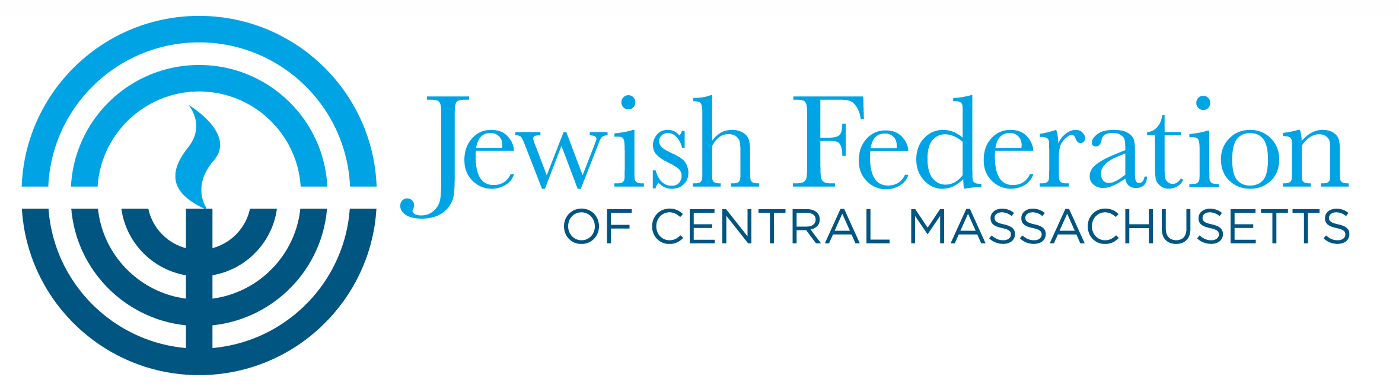
Please complete in full and return to JFCM via email: LThurlow@jfcm.org, Fax 508-798-0962 or mail:
JFCM, 633 Salisbury Street, Worcester, MA 01609
Any questions, please call 508-756-1543.

