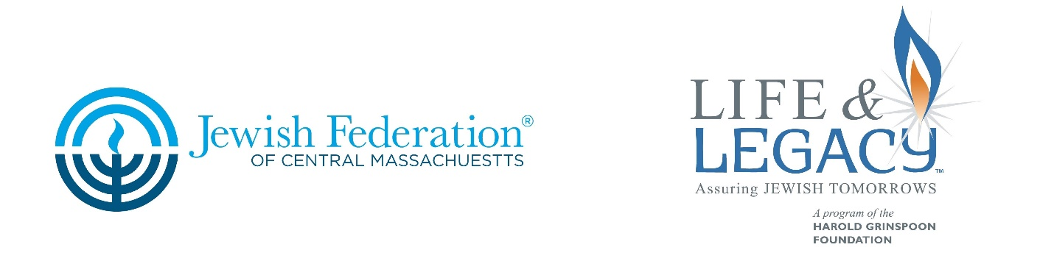
Insert text here

I always wondered why somebody didn’t do something about that. Then I realized I was somebody.
– Lily Tomlin

Sometimes it is interesting to look back at old photos and think about what places were like before we knew them. What did the Jewish Community in Central Massachusetts look like 50 years ago? What does it look like now? The Jewish community we see today was shaped by our family and neighbors of the past. Did they do a good job? They created the Jewish community in which you now live, in which you are raising your children and grandchildren. I think they created a vibrant and living history for us, but where is it headed?

Now think about the Jewish community in Central Massachusetts 50 years from now. What do you see? Are you happy with that vision? Is there more you want to do? What are we creating today that will be the foundation when our grandchildren are grandparents?

Legacy giving is, perhaps, THE most impactful way to give. Legacy commitments allow us to make substantial contributions, above what any of us could make today. Legacy gifts most commonly contribute to endowment which sustains an organization. Legacy gifts are the most important gifts an organization can receive.

That is why JFCM has partnered with the Harold Grinspoon foundation and selected 11 organizations to work with us in the HGF LIFE & LEGACYTM Program: Beth Tikvah Synagogue, Westborough, Clark University Hillel, Worcester, Congregation Beth Israel, Worcester, Congregation B’nai Shalom, Westborough, Congregation Shaarai Torah West, Worcester, Jewish Family & Children’s Service, Worcester, Jewish Federation of Central Mass, Worcester, Jewish Healthcare Center, Worcester, Temple Emanuel Sinai, Worcester, Temple Israel, Athol, and The Worcester JCC, Worcester.

According to Arlene D. Schiff, National Director of the LIFE & LEGACY program. “The time is right. This legacy program will make the most of the generational transfer of wealth, change the language and landscape of giving and provide generous and forward thinking members of the JFCM Jewish community with the opportunity to express their passion, purpose and commitment to their most valued Jewish organizations.”

Last year the Jewish Federation of Central Massachusetts was selected to participate in the Harold Grinspoon Foundation’s LIFE & LEGACY program as one of only 43 Jewish communities from across North America. Our program will launch in March of 2017. Are you ready to be the somebody who will do something about that? Start thinking about your legacy today!

For more information, contact Leah C Shuldiner at lshuldiner@jfcm.org.

