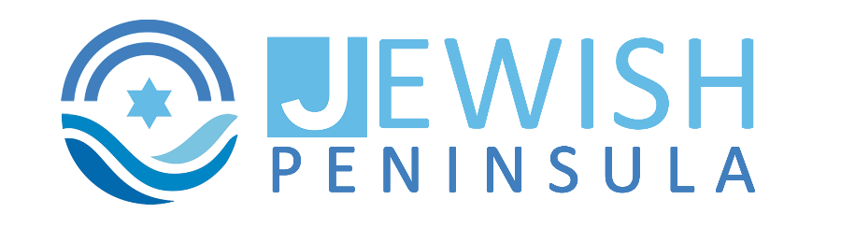

Job Title: Maintenance Manager
Location: Newport News, VA
Type: Full-time, Non-Profit
About Us: Jewish Peninsula is a lively non-profit organization dedicated to serving the needs of our local community through inclusive programs, events, and services. We are committed to creating a welcoming, clean, and safe environment for everyone who walks through our doors.
We are currently seeking a dedicated and experienced Maintenance Manager to oversee the overall upkeep, functionality, and cleanliness of our campus, including the supervision of maintenance staff.
About Our Campus:
Our multi-building campus is a thriving hub of community activity, featuring a preschool, seasonal summer camp facilities, and a main building with flexible, multi-use spaces for programs, events, and rentals. The campus also includes a synagogue, reflecting our inclusive and community-centered mission. Together, these spaces support a wide range of educational, recreational, and cultural programming year-round.
Position Summary:
The Maintenance Manager plays a key role in ensuring that our facilities and grounds are well-maintained, safe, and ready to support a variety of programs, rentals, and community events. This position requires strong leadership skills, excellent attention to detail, solid communication skills, and a hands-on, proactive approach to managing day-to-day operations.
Key Responsibilities:
- Hire, supervise, schedule, and provide support to maintenance staff.
- Ensure timely and thorough completion of all program and rental set-ups.
- Conduct daily facility inspections, addressing maintenance and cleanliness issues (e.g., lighting, restroom supplies, flooring, ceiling tiles).
- Schedule, coordinate, and oversee work performed by outside contractors, including but not limited to, the landscapers, plumber, electrician, etc.
- Keep accurate records for all mechanical equipment maintenance and service needs.
- Perform daily checks of the kitchen, ensuring refrigeration units are functioning properly.
- Monitor and adjust room thermostats to align with program needs and energy efficiency.
- Communicate any facility concerns or scheduled work to program and office staff in a timely manner.
- Review internal calendars regularly to ensure program setup needs are understood and met.
- Maintain clear, professional communication with the Controller regarding facilities and staff matters.
- Work collaboratively and with a positive attitude, even under challenging or last-minute changes.
- Coordinate with other on-campus organizations on shared facility needs and issues.
- Assist the Controller in assessing and improving ongoing maintenance strategies and plans.
Qualifications:
- Proven experience in facility management, maintenance supervision, or a related field.
- Strong leadership and organizational skills with the ability to manage multiple priorities and troubleshoot issues that arise.
- Must be an effective communicator, with the ability to work collaboratively with staff, contractors, and community members.
- Ability to work well independently and as part of a team in a mission-driven environment.
- Experience with basic plumbing, HVAC, electrical, and general repairs a plus.
- Experience with floor cleaning machines a plus.
- Commitment to upholding the values and mission of a community-based nonprofit.
Work Environment & Physical Requirements:
- Active, hands-on role requiring regular walking, lifting, and physical tasks.
- May include occasional evening or weekend hours to support events or emergencies. Flex time is encouraged for these weeks!
- Indoor and outdoor work in varying weather conditions.
Why Join Us?
- Make a positive impact on the community by supporting meaningful programs and initiatives.
- Collaborative and supportive team environment.
- Competitive salary and benefits package.
If you are a proactive, organized, and enthusiastic individual with a passion for supporting non-profit work, we would love to hear from you! Join our team and help make a difference in the lives of our community members every day by ensuring they have a safe and welcoming space to gather, learn, and grow.
How to Apply: Please submit your resume and a brief cover letter detailing your experience and why you would be a great fit for this role to Angela Morris amorris@jewishpeninsula.org.
Jewish Peninsula is an equal opportunity employer. We encourage applicants from all backgrounds to apply.

