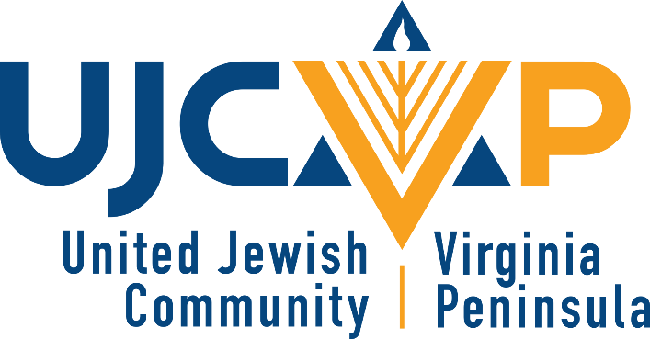
Director of Endowed Giving and Corporate Partnerships
The United Jewish Community of the Virginia Peninsula (UJCVP) is seeking a strategic, team-oriented and experienced Director of Endowed Giving and Corporate Partnerships to lead and grow our fundraising efforts.
As the Director of Endowed Giving and Corporate Partnerships you will work to:
- Cultivate relationships with Endowment fund holders and their families to facilitate their personal charitable interests and to provide a vehicle to maintain their connection to the UJCVP
- Work with donors to make planned gifts, establish Donor Advised Funds, and create Endowment Funds
- Supervise the stewardship of all spendable and endowed funds at the UJCVP, taking special care that the funds are being used at the donors’ intent, that the donor is being recognized and that we are soliciting new dollars into those funds.
- Working together with our Director of Marketing to build and enhance public relations efforts, including defining message, and creating necessary collateral.
- Establish a corporate giving program at the UJCVP and secure financial resources from major corporations in support of the UJCVP's mission.
- Write and submit grant applications, proposals, sponsorship packages, etc. on behalf of the UJCVP
Our ideal candidate for this integral role at the UJCVP meets the following criteria:
- An experienced fundraiser; experience in a Jewish communal organization is highly preferred;
- Successful track-record with experience making personal solicitations;
- A self-starter who is resourceful and maintains an upbeat, "can-do" attitude;
- Persuasive communicator both written and spoken, who can articulate a clear and inspiring case for giving;
- Extremely organized and focused, able to manage multiple priorities and meet deadlines;
- An experienced implementer with a successful track record of executing special events;
- Proven ability to develop and maintain strong relationships with staff, donors, volunteers and constituents;
- Demonstrated ability to work with and maintain confidential information;
- Authentic personal connection to the Jewish community and familiarity with Jewish traditions;
- PC literate with strong competency in all Microsoft Office Suite programs (Word, Excel, PowerPoint, Outlook) and CRM software
- Located in or willing to relocate to the Virginia Peninsula region.
How to Apply: Interested candidates are encouraged to submit a resume and cover letter detailing why you would be a great fit for this role to Eric Maurer at emaurer@ujcvp.org.
The United Jewish Community is an equal opportunity employer. We encourage applicants from all backgrounds to apply.
Job Type: Full-time
Benefits:
- 401(k) with match
- Employee discount
- Life insurance
- Paid time off
Work Location: In person, Newport News
About the UJCVP: The UJCVP is the Jewish hub of the Virginia Peninsula, connecting people of all ages, faiths and backgrounds. The UJCVP embraces and welcomes the diversity of our community. The UJCVP offers a range of social, recreational, educational, and cultural programs to foster meaningful connections. Through a powerful combination of advocacy, programming, social action, and philanthropy, we strengthen Jewish life on the Virginia Peninsula, in Israel, and around the world.

