3 Ways to Set Priorities

by John C. Maxwell
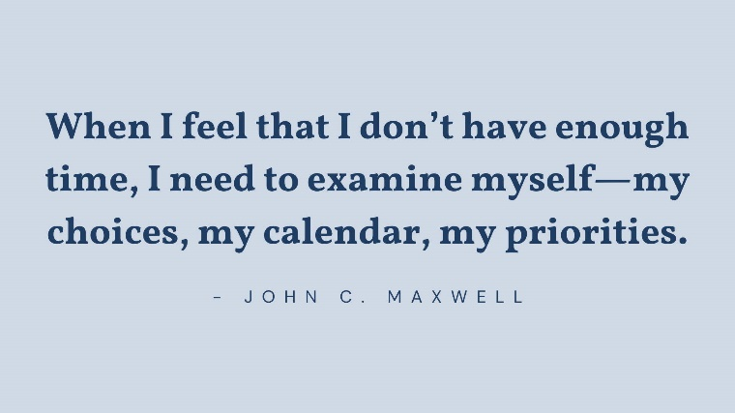
Do you have plenty of time to do all that you want and need to do in a day? I’m guessing the answer is no. I have yet to meet any busy leaders who feel they have more than enough time to do all they want.

A new way to think about and set priorities
People used to talk a lot about time management, but the reality is that you can’t manage time. Managing something means controlling it, changing it. When it comes to time, there is nothing to manage. Everybody gets twenty-four hours in a day. We can’t add another hour or subtract one. We can’t slow it down or speed it up. Time is what it is.
For anyone who leads, the question is not, “Will my calendar be full?” but “Who and what will fill my calendar?” When I feel that I don’t have enough time, I need to examine myself—my choices, my calendar, my priorities. These are the things we can control, not time. We need to determine how we will spend the twenty-four hours we have every day. That requires us to prioritize our time so we get more production out of those hours. That’s especially true for leaders because our actions impact so many other people.

3 solutions to incorporate into your prioritization strategy NOW
Having a strategy for evaluating your daily to-do list by priority is invaluable. After all, a life in which anything goes will ultimately be a life in which nothing goes well. But if you have no solutions for determining priorities other than that, you will still be too reactive instead of proactive as a leader. So I want to give you some tools that will help you with priorities in the bigger picture.

The Pareto Principle
Many years ago, while I was taking business courses, I was introduced to the Pareto principle, named for Italian economist Vilfredo Pareto. It is commonly called the 80/20 principle. I quickly saw the value of the concept and began applying it to my life. Forty-five years later, I still find it a most useful tool for determining priorities for myself, for anyone I coach, and for any organization.
The Pareto principle, when applied to business, says:
20 percent of your priorities will give you 80 percent of your production, IF you spend your time, energy, money, and personnel on the top 20 percent of your priorities.
The implications are clear: since the top 20 percent of the items on your to-do list give you an 80 percent return, you should focus on them. The top 20 percent of your staff give you an 80 percent return: focus your time and energy on them. The top 20 percent of your clients give you 80 percent of your return: focus on them. The top 20 percent of your offerings produce 80 percent of your return: focus on selling them.
Look at just about any situation, and you’ll find that the 80/20 rule applies.

The Three Rs
The Three Rs can help you become highly proactive in identifying and living your priorities. The three Rs are requirement, return, and reward.
You can discover your major priorities by asking yourself three questions based on these three Rs:
- What is required of me? Every role has responsibilities that are nonnegotiable. There are things you must do that you cannot delegate to anyone else. Do you know what they are?
- What gives me the greatest return? Knowing what activities give you the greatest return is vital. What do people continually compliment you for doing? What tasks or responsibilities do colleagues continually ask you to take on? What do you do that makes the biggest positive impact or brings in the most revenue? These are clues to help you answer the return question.
- What is most rewarding? Our best work is accomplished when we enjoy it. It gives us great internal rewards, which can be mental, emotional, or spiritual.
Your long-term career goal should be to align the tasks that answer your requirement, return, and reward questions. If what you must do, what you do well, and what you enjoy doing are all the same things, then your career priorities are in sync and you will live a productive and fulfilling life.
It often takes time and hard work to bring those things together.

Make room for margin
Parkinson’s law is true: work expands so that it fills the time available for its completion. Unless I did something intentional to create margin, I would never have it in my life.
Physician and author Richard Swenson has written extensively on the idea of margin. In his book Margin: Restoring Emotional, Physical, Financial, and Time Reserves to Overloaded Lives, he wrote, “Margin is the space that exists between our load and our limits. It is the amount allowed beyond that which is needed. It is something held in reserve for contingencies or unanticipated situations. Margin is the gap between rest and exhaustion, the space between breathing freely and suffocating. Margin is the opposite of overload.”
Instead of filling every space in my calendar, what I needed to do was create some white space.
I’m constantly on the lookout for ways to simplify my life. I try not to spend time on things that are out of my sweet spot. I delegate or dump anything that doesn’t fit into the three Rs.
My days of automatically filling up my calendar with tasks are done. Instead, I schedule white space into my calendar. With a nod to Pareto, my target is always to leave 20 percent of my time free. I would suggest that you fight for that same percentage.
https://hcleadershipessentials.com/blogs/leadership/3-ways-to-set-priorities-according-to-john-c-maxwell

