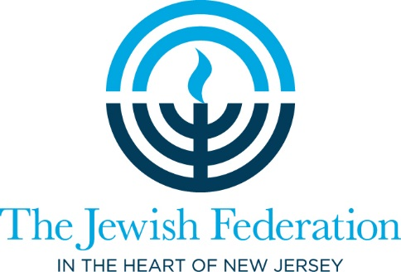

**Israel Teen Summit waiver**

I hereby give permission for my child to attend the Israel Teen Summit.

While I understand that the Jewish Federation in the Heart of NJ strives to maintain a safe environment for its participants, I also understand that there are inherent risks in some of the activities with which my child may be involved. Accordingly, I agree that the Jewish Federation shall not be legally responsible for my child’s personal health, or any injury of any kind, and I release the Jewish Federation, its partnering agencies, service volunteer locations or the staff of any of these organizations from any liability to me or any member of my family, or my property arising from or in connection with the Israel Teen Summit program. I also assume responsibility to inform the Jewish Federation prior to November 18, 2018 if my child has any specific medical needs. In the event of an emergency, I give permission to the Jewish Federation to facilitate proper medical care as it deems reasonably necessary while efforts are made to reach me. In the event there is a claim against the Jewish Federation as a result of any conduct of my child, I agree to indemnify and hold the Jewish Federation harmless from such claim.   
  
I grant The Jewish Federation in the Heart of New Jersey permission to take photographs of my child in connection with the above-identified event. I agree that the Federation may use such photographs of my child with or without my name and for any lawful purpose, including for example purposes such as publicity, illustration, advertising, and web content. I have read and understand the above. Please notify the Jewish Federation in writing if you do not want your teen’s photo included.

Name: ________________________ Date: ____________________

Signature: _________________________________