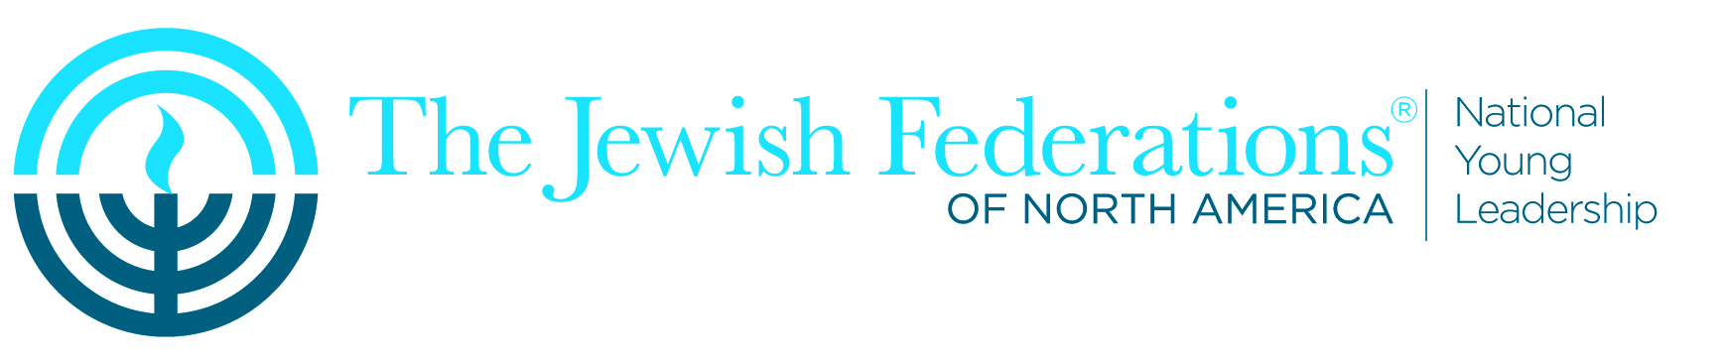

I-LEAD & National Young Leadership Cabinet Retreat
Frequently Asked Questions

Q: What is I-LEAD?
A: I-LEAD is a training and networking program for new and entry level Federation professionals sponsored by JFNA’s Mandel Center for Leadership Excellence. It will be held August 7th-9th, 2017 in Scottsdale, AZ immediately preceding the National Young Leadership Cabinet Retreat, the annual meeting for NYL Cabinet members (August 9th-12th, 2017). The location for both I-LEAD and NYL Cabinet Retreat is The Scottsdale Resort at McCormick Ranch.

I-LEAD is scheduled to start Monday afternoon, August 7th and conclude Wednesday early afternoon, August 9th. NYL Cabinet Retreat is scheduled to start on Wednesday, August 9th (time TBA).

Q: Why should Young Leadership professionals attend I-LEAD?
A: While I-LEAD is typically offered for new and entry level professionals, this year’s I-LEAD will be expanded to include training and professional development opportunities to Federation professionals of all levels who work directly with NextGen, Young Leadership, or NYL Cabinet.

Q: What does Cabinet Retreat offer – Who should attend and why?
A: We highly encourage Federation professionals who work with NYL Cabinet members in their local communities (or those who are interested in learning more about the Cabinet experience) to attend I-LEAD and stay-on for Cabinet Retreat, through Friday, August 11th (or however long is most convenient for you!).

The Retreat brings together more than 200 Cabinet members, Federation professionals and special guests for training around leadership skills and to learn with top facilitators and speakers about envisioning and building the Jewish future.

By attending Cabinet Retreat this year, you will:
- Have an opportunity to steward and deepen relationships with your donors
- Experience components of the new and upgraded NYL Cabinet curriculum together with your Cabinet members
- Learn together in real-time, allowing you to reinforce important messages when you return home
- Deepen your understanding of the NYL Cabinet experience to support recruitment and retention efforts
- Network with Federation colleagues

Q: How much will it cost to attend both I-LEAD & NYL Cabinet Retreat?
A: JFNA is inviting Federation professionals to attend both I-LEAD & NYL Cabinet Retreat as a package deal: $750 (Monday-Friday). Hotel is $119/night. You are welcome to stay for Shabbat (Friday-Saturday). There will be an additional charge to cover Shabbat expenses.

Q: Will there still be training sessions offered during Cabinet Retreat this year for Federation professionals working with NextGen and NYL Cabinet?
A: Professional development and training sessions will only be offered at I-LEAD this year. We still plan to offer a networking dinner for Federation Young Leadership professionals during Retreat.

Q: What does the Cabinet Retreat schedule look like?
A: Wednesday and Thursday of Retreat, August 9th-10th, are core learning and skills-building days. On Friday, August 11th, Cabinet will have Campaign Day, concluding with private caucuses (including a caucus for Federation Young Leadership professionals) and then leading into Shabbat. The program for Cabinet members concludes on Saturday night, August 12th, 2017.

Q: When does registration launch for both I-LEAD and Cabinet Retreat?
A: Registration will launch later this spring. For now, please save these dates.

