The Kuriansky Teen Tzedakah Corps, a program of The United Jewish Federation of Greater Stamford, New Canaan and Darien, is a teen philanthropic leadership program designed to train the next generation of community philanthropists. Corps members meet monthly on Sunday evenings to learn about the fundamentals of philanthropy and conduct a full grant allocation process.

The Kuriansky Teen Tzedakah Corps seeks to fund a minimum of one and maximum of four organizations in the region. Funding requests should not exceed $2,000. Corps members will conduct site visits and/or representatives from your organization will be invited to briefly present your proposal at an upcoming Corps meeting in Spring 2019.

Non-profit organizations: Please complete this form and submit it by emailing to Jessie@ujf.org by March 31, 2019. Please limit the narrative portion of the application to two pages. The project budget should also be no more than two pages. Thank you in advance for your proposal submission - we hope to partner with your organization!

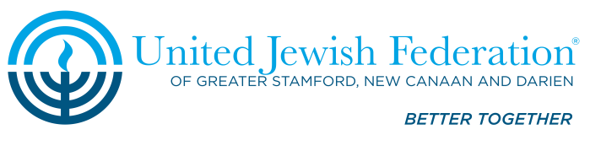
Kuriansky Teen Tzedakah Corps
2018-2019 Grant Application Form
Please complete this form and submit it by emailing to Jessie@ujf.org by March 31, 2019. Please limit the narrative portion of the application to two pages. The project budget should also be no more than two pages.
Project Name___________________________________Amount Requested________________
Organization___________________________________________________________________
Address_______________________________________________________________________
Primary Contact Person___________________________Title____________________________
Telephone___________________________E-mail_____________________________________
Alternate Contact Person_________________________________________________________
Telephone___________________________E-mail_____________________________________
A. Organization’s Mission (and how this project relates to that mission)
B. Project Description
- Purpose of funds being requested
- Statement of problem or challenge to be addressed
- Program goals and objectives, and whether this is a new or ongoing program
- Number of individuals, geographic area, and target population to be served
- Project timetable
- Plans for evaluation
- How will you make the community aware that this program was funded by Kuriansky Teen Tzedakah Corps?
C. Project Budget
- Attach table of all expenses and income (including in-kind support) related to this project. If project budget exceeds $2,000, highlight use of requested funds.
- Is this project ongoing or a one-time event? If ongoing, how will you provide future funding? If project is funded for one year, are you planning on seeking additional funding sources to fund in the second year?
- Would you be able to modify this program if only partial funding is available or is the entire amount necessary in order to implement this project? Please explain.
- Attach your organizations annual budget.
- For the following categories, please give the dollar amount spent and the percentage of your budget spent on each:
        - Programs
        - Management and Administration
        - Development and Fundraising
You may submit this information as a table or as a visual representation in a pie chart (i.e. annual report).
D. 501(c)3 Certification
Please enclose a copy of the organization’s 501(c)3 certification.

